Martin-Luther Universität Halle | M.A. Soziologie | Masterarbeit |

**Examining the Relationship between**

**Fertility Patterns and Midlife Health**

**in Germany**

Lisa-Maria Keck

Matrikelnummer: 214232815

Abgabetermin: 31. März 2022

Erstgutachter: Prof. Dr. Oliver Arránz Becker

Zweitgutachter: Dr. Sten Becker

**Table of contents**

1 Introduction / Abstract 3

2 Context, Theory and Evidence 4

2.1 Life Course Research 4

2.2 Health and Disease in Germany 6

2.3 Parenthood, Childlessness, and Health 6

2.3.1 Parenthood and Childlessness in Germany: Facts and Figures 6

2.3.2 Parenthood and Childlessness as Health Factors: Central Findings 8

2.3.3 Parenthood, Childlessness and Health: Causal Links 9

A. Biological Factors: Physical Condition and Hormones 9

B. Babies and young Children: The stressful Transition to Parenthood 11

C. Partnership status: The support of a spouse 12

D. Lifestyle factors: Becoming and remaining health-conscious as a Parent 14

E. Social support: Adult children as Resources 15

F. Involuntary childlessness: distress and regret 15

G. The Will to Fight illness as a Mother or Father 16

H. Selection effect: prior health conditions 17

2.3.4 Summary 17

2.4 First Birth Timing and Health 18

2.4.1 Age at first Birth in Germany: Facts and Figures 18

2.4.2 Age at first birth as Health factor: Central findings 19

2.4.3 Age at first Brith and Health: Causal Links and Theory 20

I. Theory: Teenage Years as Sensitive Period 20

J. Biology and Evolution 21

K. Socio-Economic Position and Instability 21

L. Vulnerability to Stress Factors 23

M. Age selection effects 24

2.4.4 Summary 24

2.5 Parity and Health 25

2.5.1 Parity in Germany: Facts and Figures 25

2.5.2 Parity and Health: Central Findings 26

2.5.3 Parity and Health: Causal Links and Theory 27

A. Biological Risks and Benefits of higher parity 27

B. Economic Burden and family policy 28

C. Social Support 30

D. Selection effects 30

E. Theory: Parity as an Accumulation of Risks and Benefits 30

2.5.4 Summary 35

3 Aims and Hypotheses 37

4 Data and Measures 38

4.1 Data and Sample Description 38

4.2 Measuring Health 39

4.2.1 The Short Form SF12v2 Health Survey 40

4.2.2 Calculating the Health Scores (Norm-Based-Scoring) 41

4.3 Measuring Fertility 46

4.4 Covariables 48

4.5 Variables and Correlations Overview 51

5 Analysis 55

5.1 Are Parents healthier than childless people? 55

5.2 What is the optimum number of kids? 56

5.3 What is the optimum age for having the first child? 67

5.4 Is women’s health affected differently by their children than men’s? 69

6 Quellenverezeichnis 72

7 Attachment 75

7.1 SF-12v2 variables list, as asked in wave 7 (see: Codebook anchor wave7) 75

# Introduction / Abstract

Can a certain pattern of having children or remaining childless have direct impacts on physical and mental health of women and men in midlife? Is there something like an ideal ‘fertility behavior’ that is generally advisable for women and men when it comes to later health outcomes in Germany?

Raising children comes with joy and hope but also with major changes and challenges for parents’ lives. The Majority of women and men in Germany, even if they have no children themselves, think of children as an enrichment of life: they represent an expression of love, a symbol of a “real home” and provide a meaning of life. On the other side they restrict personal freedom and are experienced as “handicaps” on the job market {Anonymous:2015ur p.10}. It is reasonable to assume children to have an impact on physical and mental health in the short and long run, just as other major adult roles like employment do. Studies in sociological and epidemiological life course research, especially from the USA, UK, and Scandinavia have shown specific associations between fertility and later life health for western societies and present a variety of explanation attempts that range from evolutionary biological to social mechanisms. Findings indicate that childless adults, those with 4+ children, as well as those who entered parenthood as teenagers generally suffer from worse health and show higher mortality than parents of two or three children born later in life. However, the data shows rather small effects, the correlations and causal mechanisms are not fully understood yet, and there is a broad range of social and biological influences to be considered efficacious.

As there is little evidence for Germany so far, this paper aims to test whether similar correlations between childlessness, fertility timing, fertility quantum and later, especially mid-life health can be detected on the basis of a German sample, and investigate the underlying causal effects by controlling for a set of mediators from a life course perspective.

Data is drawn from the Pairfam panel wave 7, using the oldest cohorts born 1971-73, aged 41-43 in 2014.

This paper is structured in four sections. First a brief introduction into life course research is provided. Second

The paper is structured as follows. In Sect. 11.2, we provide the theoretical background and review prior research findings. In Sect. 11.3, we describe the data we use, which come from the German Family Panel (pairfam) and cover respondents of the birth cohorts 1971–73, 1981–83, and 1991–93. Furthermore, we present our method and analyti- cal strategy in this section. In Sect. 11.4, we present our descriptive results. In Sect. 11.5, we discuss our findings from the multivariate analyses, which consist of a pooled OLS regression and fixed-effects modelling. The dependent variable is the respondent’s ideal number of children, and the main covariates are the respondent’s partnership status, employment status, and number of children. In Sect. 11.6, we discuss the implications of our findings. Kreyenfeld 2017 237

* short introduction into research contexts and theory
* Fertility, Health and the state of research that is investigating the association between both.
* In the consequent section, I will describe the data and method I am unsing.
* In the third part the analysis is done.

Im folgenden Kapitel wird die Fragestellung theoretisch verortet und es werden die Forschungshypothesen dargelegt. Anschließend werden der Datensatz bzw. das Sample und die methodische Vorgehensweise beschrieben. Im Ergebniskapitel sind die Zusam-menhänge zwischen Kinderzahl und den unabhängigen Variablen dargestellt.

# Context, Theory and Evidence

## Life Course Research

Since the 1980s longitudinal studies of large representative samples have generated databases that allow the investigation of human lives across decades {Mayer:2009cy p.416}

. The life course perspective looks at pathways across life domains, life roles, relationships and generations - always with the assumption that childhood (if not in utero) but also adulthood history is strongly impacting later life outcomes. Major Handbooks give an overview of the interdisciplinary research field (see: Mortimer:2003vm; Shanahan:2016cm} The longitudinal approach has become “the current gold standard of quantitative social science” {Mayer:2009cy p.414}, working with nationally representative retrospective and prospective surveys like the German Socio-Economic Panel, German Life History Study and the German Family Panel pairfam.

**Health across the life course,** the fastest growing area in life course studies, focuses on pathways to psychological and physical health outcomes and mortality {Mayer:2009cy p.421}and has blossomed in the last two decades as a response to the limited medical models of disease {Kuh:2003vb p.781}. It’s all about understanding risk factors at different life stages, patterns of health distribution in society and eventually translating knowledge into policy recommendations to benefit public longterm health.

The broad idea of health has been operationalized in many different ways: chronic disease, disability, mortality, well-being and so forth.

The majority of adult health resp. disease is explained as consequences of the complex accumulation and interaction of biological, behavioural and social influences over the life course of individuals and cohorts. Natural factors (such as genetics, foetal growth, birth weight, childhood illness, body height, hypertension), physical circumstances (pollution and other environmental stressors), political environments (access to health services, social disruptions), socio economic positions throughout life (education, occupation, income), and lifestyle factors (smoking, diet, exercise, social networks, stress) have been intensely investigated and interrelated as health formative variables by natural and social scientists {Lynch:2005dp p.2ff, Blane:2007ff p.32}. In social Sciences especially the effects of socioeconomic factors on health have been focused on and found to be highly relevant {see Blane:2007ff}.

Fertility as a health determinant is a less explored field but nevertheless boasts a huge body of evidence by now and the most common diseases have been investigated in coherence to fertility in western societies.

Considering the multi-disciplinary perspective in life course research, it also attempts a synthesis of theoretical models to explain the relationship between exposures during life and later disease or health. Literature names a variety of concepts {see Kuh:2003vb, Lynch:2005d, Blane:2007ff} and some authors criticize the lack “of a coherent body of theory {Mayer:2009cy p.423}.

A selection of models that can support the purpose of this paper that may well be combined, as well as relevant facts and findings will be further described below. To keep it within reasonable bounds and since health outcomes are highly cohort and culture specific, I will concentrate on recent findings, i.e. from 2000 and later, in western societies, set an focus on the age group 40-45, and provide a framework of fertility facts and trends in Germany.

## Health and Disease in Germany

Typical for a western industrialized country, the most common diseases diagnosed in Germany are diseases of the circulatory system and cancer with, followed by dementia, illness of the lower respiratory passages, and diabetes – all with considerable gender and age differences {RKIRobertKochInstitut:2015wz p.24ff}.

Looking at the deaths due to illness in the age group of 40-45 in 2015 (corresponding to the sample of this paper), it is noticeable that around twice as many men (8639) as women (4770) suffered from premature death. The by far most important death causes were tumors and cancer (48% of female deaths, 25% of male male) and illness of the circulatory system (14% resp. 25 %).

Mental illness and behavior disorders - including anxiety, depression, insomnia, alcohol and drug addiction, accounted for 3% resp 6 % of deaths {SterbefalleSterbez:56lK_IX9}. Depression, however, is the health issue with the highest disease burden, resulting in much longer periods of inability to work than other diagnosis: about 13% of women and 6% of men between age 18 and 64 are affected {RKIRobertKochInstitut:2015wz p.112f}.

Insgesamt schätzen Frauen ihre Gesundheit schlechter ein, sterben aber später.

## Parenthood, Childlessness, and Health

### Parenthood and Childlessness in Germany: Facts and Figures

About 25% of women and 33% of men at age 41 are childless in Germany {Kreyenfeld:2017kq p.106}. At this age the state of parenthood is predominantly permanent as births later in life are rare {Destatis:2012uh p.28}. Childlessness here is used in its demographic sense describing people who don’t have any own biological children but might have step-, foster or adopted children.

The number of men and women who remain childless has continuously increased over the past decades, which is a major reason for the low fertility rate in Germany {Destatis:2012uh p.27f}. Their share is particularly high in the three German city states and among academics, of which around every third woman remains nulliparous and particularly low in former East Germany {Destatis:2012uh p. 32, Bujard:2016uu, Dorbritz:2014vc p.256}. But the birth patterns converge more and more with an overall trend to more cildlessness (Kreyenfeld & Konietzka, 2017). Male Childlessness, however is higher in former East Germany, because many women left in the nineties, causing a male surplus and demographs estimate the number of childless elderly male to soon be especially high in the New Laender <https://www.demografische-forschung.org/archiv/defo1702.pdf> p.3.

There is a strong correlation between parenthood and women’s educational level: the higher the education, the higher the childlessness and the lower the average number of children, at least in West Germany, where non-graduated women show childlessness of 18.2 percent and highly qualified women remain childless by 30.9 percent. An interesting exception was found amongst well educated women with traditional and conservative values, who show similar rates of childlessness as the disadvantaged {Anonymous:2015ur p.39}. In East Germany the education level does not affect childlessness levels. {Dorbritz:2014vc p.256}.

While the educational gradient in Germany is recently described as diminishing i.e. the childlessness for highly educated women has stopped to increase, it keeps increasing for low and medium educated, as well as migrant women, so a further overall increase of childlessness in Germany can be expected {Bujard:2016uu}.

Being in a stable relationship is by far the most important determinant of whether people form and realize positive fertility intentions in Germany, followed by financial stability {Kuhnt:2013tq p.22f}. This is consistent with the idea that most people – especially the highly educated - are continuously postponing childbearing rather than rejecting it altogether (Berrington, 2017) .

It has been estimated that internationally about 9% of women (20-44) in a partnership remain childless due to biological reasons (infertility and sterility, prevalence of 12 months) of which 56% seek medical assistance {Boivin:2007bg}. Recent data shows how women’s sterility rises after age 35 (12% unable to have a child) and especially between age 41 (50%) and 45 (90%) coming with difficulties in conceiving and higher risks of fetal loss {Eijkemans:2014kv}. Men’s fertility is biologically stable up until old age {Anonymous:2015ur p.13} but bound to the age of their female partner.

Others, who are biologically able to have children, may remain childless for social reasons, i.e. being without a suitable partner or with a partner who does not want children or repeatedly delaying the decision to have a child at a certain point in their lives until it is “too late” {Carmichael:2007jo}.

### Parenthood and Childlessness as Health Factors: Central Findings

Being a parent is often hypothesized to have an overall health promoting effect for both women and men, while childlessness is generally associated with worse health conditions {Grundy:2007kz, Jaffe:2009jc, Modig:2017kn}.

Having at least one child correlated with lower death risks and an increased life expectancy of averagely 1.5 years for women and 2 years for men at age 60 in Sweden The same study found an increasing association with parents age {Modig:2017kn}.

In Norway cancer patients, female and male aged 20-63, with children were found with a significantly lower mortality than that of the childless (up to 25%, depending on the type of cancer). However, the advantage didn’t show up in cases of breast and ovarian cancer or in cases where the children were already adults (Kravdal, 2003).

An U.S. study investigated middle-aged women (40-59) and also found a post-reproductive mortality advantage for white mothers of 2-3 compared to childless women - not so for the black study participants {Spence:2009ha}. UK studies found an negative effect of childlessness only when compared to parents of one or two children {Doblhammer:2000cg} or could not find any association between childlessness and physical illness {Grundy:2015gz}.

With regard to mental health in mid-life and old age, a study from Norway found higher usage of antidepressants for childless men and women compared to parents {Kravdal:2015jp}. American studies however detected no general psychological health differences for mid-aged parents {KoropeckyjCox:2007ch, Evenson:2005ii} and elderly parents (70+) {Zhang:2001bo} compared to childless individuals. Only early mothers – mothers who had their child before age 19 - showed a significant mental health disadvantage, related to singlehood, marriage disruptions and poorer socioeconomic status {KoropeckyjCox:2007ch}. The same researcher two years later even found health advantage and less depression among the childless (across all marital status groups) in mid- and late life. Highest levels of depression were observed among never-married mothers and formerly married mothers who had lost their children {Bures:2009df}.

A systematic review on international studies up to 2003 on women found overall highest mortality for childless women compared to mothers but concluded that research results were not consistent and effects were generally small {Hurt:2006io}. Another review evaluating international studies of the years 1999 - 2009 on psychological wellbeing stressed how the influence of parenthood and childlessness varies over the life course and how effects vary along many confounding and mediating factors {Umberson:2010iz}.

Obviously, it is tricky to compare study results from different countries, age-groups, cohorts, using different operationalizations of health and controlling for various sets of mediators in the analysis but a few key findings and explanatory concepts will be summarized in the following to structure research findings and explain some causal links.

### Parenthood, Childlessness and Health: Causal Links

#### Biological Factors: Physical Condition and Hormones

With regard to women, there certainly are biological pathways from pregnancy and child bearing resp, remaining nulliparous to female health, whereas they don’t necessarily run in the same direction.

While maternal depletion and the risk of dying during pregnancy and postpartumcan still are significant factors in developing countries {Hurt:2006io p.55}, the maternal mortality in Germany is below four deceased mothers per 100,000 live births (0,004%) {Bevolkerungsforschung:anvLSAyc} and practically not relevant.

Still, there is a variety of diseases for which acute risks are heightened by pregnancy. The US department of Health and Human Services lists them on their site: gestational hypertension, gestational diabetes, and degenerative changes in arterial walls, preeclampsia, iron deficiency anemia and others (Services, 2017).

The risk of cervical cancer found to be positively associated with childbearing and increases with the number of births {Parazzini:1998bb} and another biological risk factor, that currently is being investigated, is Microchimerism: fetal cells invade the maternal immune system during pregnancy, lifting maternal tolerance of the fetus, and remaining in the mother’s blood and tissues for decades. This potentially leads to greater cancer vulnerabilities and increased autoimmune disease susceptibility in the mothers body {Boddy:2015dx}.

Gesundheitsveränderungen infolge einer Familiengründung und -erweiterung sind Resultat eines Zusammenspiels evolutionärer, biologischer und sozialer Mechanismen. Aus medizinischer Sicht sind insbesondere die physiologischen Vorgänge im mütterlichen Organismus von Interesse, die sich als ein möglicher Zündmechanismus für spätere Heilungs- und Krankheitsprozesse erweisen können. Der schwangerschaftsbedingte Austausch mütterlicher und fetaler Zellen (**fetaler Mikrochimärismus**, [Abbildung 2](https://books.publisso.de/en/publisso_gold/publishing/books/overview/46/176#Abbildung 2)) kann bei Müttern u.a. Autoimmunerkrankungen wie Arthritis und Schilddrüsenfehlfunktionen auslösen, kann aber auch vor einer Brustkrebs- oder Alzheimererkrankung schützen (fetale Zellen wurden seltener im Gewebe von erkrankten im Vergleich zu gesunden Müttern gefunden, zur Vertiefung siehe [[4](https://books.publisso.de/en/publisso_gold/publishing/books/overview/46/176#rwPubRef~5189)]).

Auch **hormonelle Veränderungen** während der Schwangerschaft und Stillperiode können Brust-, Eierstock- und Gebärmutterkrebs vorbeugen, hinsichtlich Diabetes und Herz-Kreislauf-Erkrankungen jedoch verstärkend wirken.

[4] Boddy AM, Fortunato A, Wilson Sayres M, Aktipis A. Fetal microchimerism and maternal health: a review and evolutionary analysis of cooperation and conflict beyond the womb. Bioessays. 2015 Oct;37(10):1106-18. DOI: [10.1002/bies.201500059](https://dx.doi.org/%2010.1002/bies.201500059)

<https://books.publisso.de/en/publisso_gold/publishing/books/overview/46/176>

On the other hand, female reproductive organs (except the cervix) seem to be health-promotingly stimulated by hormons during pregnancy and lactation. Mothers, especially if they breastfed their offspring, were found to have lower risks when it comes to breast cancer.

However, looking deeper into the data, there runs no clear line between parents and non-parents. Grundy and Kravdal found quite different results for different parity groups in Norway. It was only mothers of three and more children that showed statistically significant health benefits when it came to breast cancer {Grundy:2010gq p.1850}. Multiparous women were also found to have a lower risk of suffering from and endometrial uterus cancer {Rieck:2006bq p.237} and a 30 to 70% lower risk of suffering from ovarian cancer as compared with nulliparous women {Salehi:2008hy p.309}.

This brings to mind that one child might not be enough to benefit from the direct physical health advantages of pregnancy and childbearing as a woman.

When it comes to men, studies have found that pregnancy and childbearing also affect their hormonal balance, reducing their testosterone levels, potentially reducing aggressions and increasing empathy (Edelstein et al., 2015), but it remains unclear whether this is linked to behavioral changes and later health outcomes.

As many studies have found the parenthood-health correlation to affect both, women and men psychosocial factors seem to play an elevated role for the association:

#### Babies and young Children: The stressful Transition to Parenthood

Pregnancy and the transition to parenthood can take a toll on some new parents mental health and go along with depressive symptoms. During the first year post partum, 4.4% of mothers and also 4.0% of fathers were newly suffering from postnatal depression in Spain {EscribaAguir:2011hq}. In the U.S. new parents residing with young children showed higher levels of distress and depression than empty-nest parents and childless people in the U.S. {Evenson:2005ii p.349}. These outcomes are partly ascribed to hormonal changes that happen during pregnancy and “co-pregnancy” and can remain over years, but more so to psychosocial and personal factors such as marital problems {EscribaAguir:2011hq, Edward:2014gk,}.

A meta analysis of 97 research publications approved that parents generally, but especially mothers of infants, report lower marital satisfaction due to “role conflicts and restriction of freedom” compared with nonparents {Twenge:2003hv p.574}.

Parenthood often represents a cesura in the life course, a relapse into traditional role allocations even for previously egalitarian couples with similar education and career goals for women and men {Anonymous:2015ur p.15}. Minor children increase housework hours and partnership strains significantly more from women’s perspective {Nomaguchi:2003gwa p.370}. Even though fathers involvement in child care has been increasing over the last decades, women mostly fill the role of children’s caretaker, even if they also work outside the home {Bianchi:2000hp p.404}. In societies where women have live professional lives just as men, but are still bearing the majority of house work, their fertility drops dramatically until men finally step in to share the burden – generally with a delay of around 30 years {Sacerdote:2008hs p.1}.

Researchers have shown that marital quality is directly linked to physical and psychological well-being {Proulx:2007dl} and work-family conflicts and parental stress can go along with serious health issues (such as earlier hypertension) for women {Wickrama:2001ek}. The latter association did not exist for men.

Other researchers could not confirm the association between new parenthood and depression for the U.S.; they found lower levels of self-efficacy but at the same time better social integration into a community among their new parents group {Nomaguchi:2003gwa p.363}. Social relationships are generally health relevant in any life stage by shaping health behaviour: “Without social ties, distress emerges and health fails”{Umberson:2010hm p.152}.

A study on the basis of the German Socio-Economic Panel even found an overall increased life satisfaction for parents in the year prior and of their first birth in comparison to their life satisfaction three to five years before {Margolis:2015fd p.1154ff}.

#### Partnership status: The support of a spouse

In Bezug auf gesundheitliche Auswirkungen kommt der **Ehe** – und abgeschwächt auch dem Zusammenleben ohne Trauschein – ein **Protektionseffekt** zu, der mutmaßlich aus finanziellen Vorteilen (z.B. durch gemeinsame Haushaltsführung), der gegenseitigen sozialen Unterstützung sowie aus sozialer Kontrolle (z.B. durch Überwachung der Einhaltung ärztlicher Empfehlungen) resultiert. Bei sonst vergleichbarem sozialen Hintergrund schätzen neuere Studien die Restlebenserwartung bei verheirateten Männern im Alter von 50 Jahren um elf Jahre, bei Frauen um acht Jahre höher ein als bei Ledigen [[5](https://books.publisso.de/en/publisso_gold/publishing/books/overview/46/176#rwPubRef~5190)]. Umgekehrt sind **Paarkonflikte, Trennungen und Scheidungen** bei betroffenen Frauen und Männern assoziiert mit

* kardiovaskulären Erkrankungen,
* Stress und Depressivität (temporär oder längerfristig),
* erhöhter Inzidenz chronischer Krankheiten und funktionaler Einschränkungen,
* Substanzmissbrauch (in einigen Studien häufiger bei Männern gefunden),
* einer deutlich verringerten Restlebenserwartung nach einer Scheidung im Vergleich zu Verheirateten (Männer: fast zehn Jahre, Frauen: fast acht Jahre geringer).

https://books.publisso.de/en/publisso_gold/publishing/books/overview/46/176

Partnership status moderates a good part of the association between parenthood and health. Especially the stabilizing conditions marriage - which highly correlates with parenthood - could potentially act as an effective physical and mental health protector. Never married and divorced cancer patients, for example, show 7 to 15% higher mortality than the married in Norway {Kravdal:2001ey p.357}.

Some studies suggest that men’s health is generally more affected by their partnership status than women’s or as a 2003 cancer survival study from Norway concludes: “a man appears to benefit from having a wife as well as having children […].“ For women they couldn’t find such obvious beneficial effects of marriage, but obvious detrimental effects of divorce (Kravdal, 2003)

Similar effects were found in Australia and the Netherlands where never married and divorced elderly men showed worse general health, worse health behavior (daily fruit consumption, smoking, physical exercise) and increased depression compared to their currently married counterparts in Australia and the Netherlands. Among women, again no marital status group emerged as having consistently poor or good health {Kendig:2007ja p.1480f}.

For certain subgroups partnership status intensifies the relationship between parenthood and health outcome {Modig:2017kn}. Children come with costs and rewards and certain types of parents seem to really benefit from having children, while others rather suffer from it. Unmarried couples were found to be more affected by the costs while the married benefit more from the rewards {Nomaguchi:2003gwa p.370}. Single Parents reported significantly more symptoms of depression than the married or cohabiting parents {Evenson:2016ii p.341}.

The combination of relationship status and parent’s gender seems to be especially potent for the association between having kids and wellbeing: With regard to young parents, an U.S. study found that married new mothers enjoyed especially good mental health, while never-married new fathers showed especially bad mental health compared to all the other groups {Nomaguchi:2003gw p.370f.}. And when it comes to remaining childless, it is the divorced, widdowed and never married men who suffer most; Their mental health in old age is significantly worse than women’s in comparable circumstances {Zhang:2001bo; Kendig:2007ja}. Men – at least in late life - are described as being more dependent on their spouse and children as resources of care and social control. If both resources aren’t available this can have especially detrimental effects for their health condition (Wenger, 2001).

When controlling for marital status, effects of general parenthood on health are reduced, but effects often remain{e.g. Kravdal:2003ee p.264}.

#### Lifestyle factors: Becoming and remaining health-conscious as a Parent

As mentioned above, having a spouse can positively affect life style choices - and so can having children. Grundy and Kravdal examined cause specific mortality in Norway and after controlling for education, marital status and geographical factors, they found positive associations between low parity (having 0-1 children) and alcohol related deaths, accidents and violence {Grundy:2010gq p.1851}. Finnish Parents were generally found to smoke less, eat healthier and exercise more than their childless peers in old age – independant of their marital status {Kendig:2007ja p.1480}.

Having offspring probably motivates a more health-conscious and safe lifestyle. The willingness and social pressures to change one’s behaviour already start during pregnancy and remain over the life course.

On the other side, it seems as if people – especially men - with very active lifestyles have problems adapting to the demands and constraints of parenthood. Fathers, who very frequently participated in leisure activities before the birth of their child, were found to report reduced mental well-being after the birth in Switzerland. For women this association wasn’t true, they generally showed higher rates of well-being after becoming a mother (Roeters et al., 2016).

#### Social support: Adult children as Resources

As children grow and parents progress in their lives the costs and benefits of parenting change: On the upside there is more emotional support and better social integration {Nomaguchi:2003gwa p.371} than with young kids or no kids. Adolescent children can enhance the family’s social capital by generating sources of support outside the family {Offer:2007vf, Antonucci:2003gi} and being a source of support themselves.

Research from the UK points out that elderly parents had better chances of regular face-to-face contact than their nulliparous reference group and that the contact with a child can predict the receipt of help two years later {Grundy:2012jw}. Accordingly, elderly childless individuals might suffer from support deficits {Dykstra:2016hc}. It also found that especially having a daughter made the difference, more so than the number of children {Grundy:2012jw}. This makes sense since female relatives mostly bear the brunt of the care work {Nowossadeck:2016ta p.3, Bott:2017ks}. However, Swedish research could not find any association between gender of the child, parenthood and mortality {Modig:2017kn}.

On the downside, the support that children provide for their parents is relatively uncertain: the offspring may be unavailable and unwilling to assist or even remain dependant on their parents and therefore rather present a source of distress and disappointment for their parents {Bures:2009df p.72}. How difficult parent-child relationships are linked to diminished psychological well-being of parents (50-84 years) was shown by for an U.S. sample {KoropeckyjCox:2002bj}.

#### Involuntary childlessness: distress and regret

While parenthood and childlessness have mostly become a matter of choice, some remain childless involuntarily, may it be due to infertility or career pressures, and consequently suffer from decreased mental health (Hewlett, 2002).

The line between involuntary childlessness and childlessness by choice is blurry and changing over the life course but estimates show that only few individuals actually wish to remain childless.

Remember: About 25% of women and 33% of men at age 41 are childless in Germany {Kreyenfeld:2017kq p.106}. Around 13% of childless citizens between age 20 and 50 state the conscious choice to remain “childfree” {Anonymous:2015ur p.11}. The grand majority sees themselves having a child now or later and regard their current situation as a temporary transition phase. Around 25% were found to be involuntarily childless, of which more than 90% over age 40 try to fulfill their wish for a child since more than five years {Anonymous:2015ur p.11 and p.98}. Many are lacking a stable partnership (26% of women, 42% men), have too stressful jobs (19% / 16%) or are diagnosed with infertility (8% on average and 27% at age 40-50 / 4% and 8%) {Anonymous:2015ur p.88}. The numbers also show that women more often remain inadvertently childless despite being in a stable partnership, men on the other side cannot fulfill their wish for a child because they haven’t found a partner {Anonymous:2015ur p.83}.

To inadvertently remain childless can become a stress factor and studies suggest that the attitude towards childlessness might actually be more relevant for health outcomes than childlessness itself: Koropeckyi-Cox found that childless women (50-84) with “incongruent attitudes” towards childlessness are lonelier and more depressed than women who are at peace with their nulliparity in the U.S. For men she didn’t find a similar link {KoropeckyjCox:2002bj p.964}. In Canada involuntary childless women (45+) reported worse overall wellbeing, less autonomy and more regret than voluntary childless women {Jeffries:2016dt}.

Women in partnerships experience a greater pressure compared to men when it comes to having children: being a ‘real’ woman is still closely related to motherhood {Anonymous:2015ur p.160}, with advancing age women increasingly feel as the sole cause for the couples physical fertility problems {Anonymous:2015ur p.93}, and women more than men fear being dismissed by others as egoistic, irresponsible and hedonistic or otherwise as pitiful and deficient {Anonymous:2015ur p.161}.

The opposing phenomenon ‘regretting motherhood’ is lately discussed in the public but thus far lacks investigations to estimate its prevalence {Donath:2017wq p.30}.

#### The Will to Fight illness as a Mother or Father

As Norwegian Researcher Kravdal found siginificantly better survival rates amongst parents, compared to childless cancer patients, he hypothesized: “those who have children, of any age, are particularly eager to put up a ﬁght when faced with a potentially fatal disease” (Kravdal, 2003). This theory is hard to test with the given Smaplee though. MORE!?

#### Selection effect: prior health conditions

Subfecundity, sterility and other health conditions can be a cause or a reason to remain childlessness {Kravdal:2003ee p.264; (Kendig et al., 2007)}. As early health conditions are directly related to later life health {Blane:2007ff p.32}, this might be underlying link for the correlation between childlessness and later health. Vice versa it is probably the physically robust and mentally stable women who decide on having children, especially more than one. For this reason, it makes sense to control for prior health conditions.

**Health related selection effects** can play a role for the association between parenthood and later health and need to be controlled for. Poor early health can be a cause or reason to remain childlessness {Kravdal:2003ee p.264} and, as it is also directly related to later life health {Blane:2007ff p.32}, it might be the real reason for the correlation between childlessness and later health. Vice versa it is probably the physically robust and mentally stable women who decide on having children, especially more than one. For this reason it makes sense to control for prior health conditions.

### Summary

To sum it up, we have to deal with mixed resp. contrary evidence and small effects in a very complex relationship. It is difficult to imagine parenthood not having an impact on mental and physical health, as other social institutions like marriage and employment do {Evenson:2005ii p.341}. However, given the heterogeneity among parents and childless it is possible that positive and negative effects neutralize each other {Evenson:2005ii p.355} for individuals over the life course and also between parity groups. The experience of parenthood or childlessness seems to be highly dependent on the context and can have very different effects on individuals - as described above. Moreover, the social meaning of parenthood and childlessness has changed a lot in recent decades and psycho-social effects possibly vary across cohorts {Umberson:2010iz p.3}.

If anything, parenthood seems to make more of a difference in women’s lives; Childlessness seems to negatively affect men more than women {Dykstra:2016hc}.

To dig depper into it’s health effects, the concept of parenthood needs to be narrowed down to check specific types of parenthood against each other and against childlessness. I decided to investigate middle aged women and men (40-44) in the Year 2014/15 and concentrate on the factors parents age at first birth and completed family size, based on based on what a lot of international studies have been found to be decisive factors.

## First Birth Timing and Health

### Age at first Birth in Germany: Facts and Figures

The mean age at first birth in Germany has constantly been rising since 1970: from 24 to 29.8 years by 2017 {'Eurostat', 'Destatis'} and a further rise is expected. In the years before the reunification 1960-1989 East German women were much younger than their West German counterparts (22-23 years) at their first birth (Bujard & Diabaté, 2016), which could be relevant for the sample of this paper (born in 1971-73, teenage years 1981-1991). The numbers converged very quickly in the 1990s but East Germans today are still slightly younger at first birth than West Germans and more likely to have children outside of marriage and as single parents (Kreyenfeld and Konietzka 2017 p.98).

For official statistics in Germany women between 15 and 49 are generally assumed to be prolific, i.e. capable of bearing children. An early first birth generally is considered a teenage birth before age 20 for women, for men it is often defined as a birth before age 23. The term “late birth” is used more inconsistently, it mainly refers to childbearing at ages after 35.

The number of live births to teenage mothers (before the age of 20) in Germany is very low by international comparison and ever declining: it’s share in the total fertility rate was at 1.7 percent in 2014

{Destatis:2016td}. Since the 1950s the number of teenage fertility has been strikingly higher in the East German Counties with maximum rates of almost 21% in the 1970s (the rate in the West was around 9% at that time). During the eighties, up until the early nineties the rates still differed quite a lot, (see abbildung xx in the appendix: BiB 2014). Today, the difference still exists on a rather low level (1,9% in the West, 4% in the East in 2012) (Bevölkerungsforschung, 2014).

On the contrary the share of first births after age 35has increased by 40% in ten years 2006-2016 (Bujard & Diabaté, 2016). The number of births after 45 is still very low, but tripled since 2000 from 0.1 percent (706 babies) to 0.3 percent (2.268) of all live births in Germany in 2015 {Destatis:2017vt}. A big part of late births happens in the academic milieu (Bujard & Diabaté, 2016).

Men’s fertility in Germany was not covered up until 2016 since official statistics lack information about the father’s age at birth. In 2016 researchers estimated missing paternal ages on the basis of birth data between 1991 and 2013, using imputation methods and sensitivity analysis. They suggest that, compared to female fertility, male fertility is realised later and spread across a broader age range {Dudel:2016cn p.1556}. Their estimation for the year 2010 says that the mean age of German fathers at childbirth was 33.1 – on average three years older than mothers – and keeps rising parallel to the mothers age (female partners are on average, three to four years younger than her male partner). While as much as 6 percent get their children after the age of 45, the large majority of men have completed their fertility history by that age. Unfortunately there are no details on age at first birth or teenage fatherhood.

### Age at first birth as Health factor: Central findings

Grundy and Kravdal examined mortality patterns of all Norwegian citizens and showed an overall positive association between early first birth and mortality, and an overall negative association of late age at last birth and mortality for men and women likewise (Grundy & Kravdal, 2007). For the U.S. population Mirowsky stated generally improving health outcomes with increasing age at first birth. The association was found to be “linear for men and parabolic for women, with maximum health predicted for mothers who had a first birth around age 30.5” (95% CI 26.9-34.1) {Mirowsky:2002gj p.315 and 329}.

Having children late in life was in some studies associated with health advantages (Grundy & Kravdal, 2007; Grundy & Tomassini, 2005), in others with higher mortality risks (Spence & Eberstein, 2009).

So, how could the association of age at first birth and later life health be explained?

### Age at first Brith and Health: Causal Links and Theory

#### Theory: Teenage Years as Sensitive Period

Natural sciences use the concept of critical periods, which says that an exposure during a specific time frame in life has long-lasting effects on the body’s structure and function that may eventually result in disease later in life. The causal effect does not exist when exposed at a different life period. Critical periods are mostly times of fetal development, childhood, and adolescence {Kuh:2003vb p.780, Lynch:2005dp p.5}.

In social sciences the similar concept ofsensitive periods can help understand the importance of exposure timing. During sensitive periods, exposures have greater effects on the individual’s future condition than the same exposure during other time periods in an individual’s life {Kuh:2003vb p.781, Lynch:2005dp p.6}. Outside sensitive periods the correlation between treatment and outcome does not completely vanish, but it is distinctly smaller. To illustrate the concept of sensitive periods, consider the following example:

A study on women who experienced the Nigerian civil war (1967-1970) found the teenage years to be the most sensitive time frame for physical development. Adult health, measured in body height, didn’t differ much for individuals exposed to conflict and famine between the fetal year and age twelve. An average reduction in adult height of 0.75 centimeters relative to unexposed women of the same cohort was found for them. But those exposed at age 12 to 16 showed a striking 4.53 cm deficit in body height {Akresh:2012bm p.274f.}.

Sensitive Periods might be highly complex and culture-specific, but it is reasonable to assume that the impact of having children on later health is stronger during adolescence than later in life. To explain this link, biological-evolutionary and socioeconomic, and mental processes are hypothesized and explained below.

#### Biology and Evolution

Pregnancy, parturition, and lactation are challenging for the female body and can change women’s physiology permanently, supposedly even more for younger women {Pirkle:2014il p.2}.

The “Evolution of senescence” of Kirkwood and Rose is consistently mentioned as one evolutionary approach for understanding the effect of early motherhood on women’s physiology. It assumes that in metabolic trade-offs scarce resources are directed either towards physical maintenance or towards fertility from the same supply within an organism. Reproductive activity reduces survival also through non-metabolic trade-offs by increased risk exposure and wear-and-tear. The authors conclude that “simply rescheduling fecundity to later ages will increase survivorship” {Kirkwood:1991iv p.20} and there are current studies that can support this idea:

Adolescence is known as a critical period for accumulating bone mass and childbearing might interfere with it. A Korean study found lower bone mineral density and increased risk of osteoporosis for postmenopausal women with histories of adolescent pregnancy – after adjusting for a variety of factors including SEP, exercise, smoking and parity {Cho:2012du}.

A study based on a Norwegian Sample found that the inclusion of sociodemographic variables generally weakened correlations between age at first birth and cause specific mortality, but had no noticeable effect on breast, ovary and uterus cancer. The risks for breast cancer increased, while the risks for ovary and uterus cancer decreased with age at first birth {Grundy:2010gq p.1853f.}.

Other studies reveal significant associations between young maternal age at first birth and high blood pressure, diabetes, and chronic lung disease {Pirkle:2014il p.6} and heart problems in midlife and old age (Lee & Ryff, 2016)

#### Socio-Economic Position and Instability

In western societies, early childbearing can be a symptom of a disadvantaged background and a pointer to a weak start into adulthood: As humans mature biologically about ten years before they mature socially and professionally{Mirowsky:2002gj p.316}, having a teenage-birth is often correlated with less completed years of college education {Hofferth:2001vj}, increased probability for divorce, worse status on the marriage market i.e. higher risk of partnering with poorly educated and unemployed {Ermisch:2005hm}, and an overall tendency to having bigger families {Grundy:2016cl p.259} and less economic well-being in the long run. All these factors are closely related to the socio-economic position SEP and health themselves. Therefore, the associations between timing of childbirth and later health may well be moderated by socioeconomic factors.

It is well established that socio-economic position SEP – including professional status, income and education – is a strong determinant of health and mortality

{Hayward:2004jm, Smith:2004vf} as well as mental well being {Miech:2000ko}. In most chronic diseases distinct differences can be observed with a consequent plus of 13 to 14 years of good health that people on highest socio economic positions are enjoying, compared to people on the lowest positions in Germany {RKI:2015fe p.22}. This goes along with the distribution of the most important health risks, that low status people are more prone to: malnutrition, overweight, hypertension and smoking {RKI:2015fe p.26} as well as physical inactivity, dyslipidemia, negative emotions and stress {Grundy:2015gz p.128, Lampert:2013ei p.514, Gallo:2003cf}.

The association between status and health is already apparent at birth when babies from less wealthy and less educated families have lower birth weights than babies from more advantaged households {Case:2010va p.1}. Childhood disadvantage is a strong predictor for poor socioeconomic outcomes later in life (mostly moderated through educational attainment) (Mckenzie et al., 2011) as well as mortality (Galobardes et al., 2004, 2008) and was found to be a strong risk factor for early parenthood (Allen et al., 2007). So, early life conditions are likely to be a central causal root of the relation between first birth timing and midlife health.

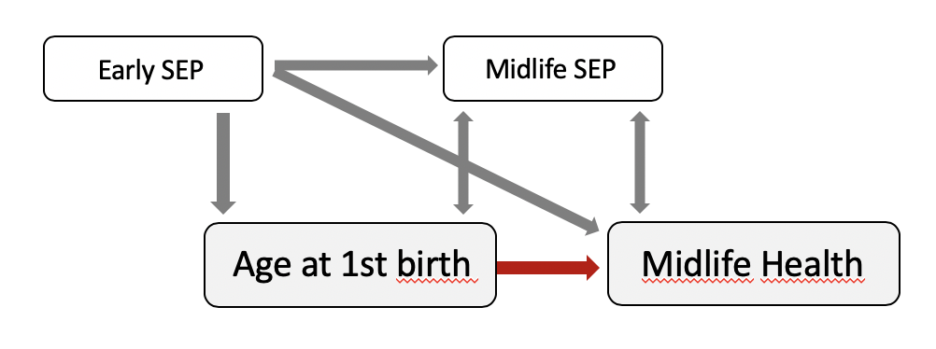

Figure 1: Model of the links between SEP, age at first birth and midlife health

These coherences are part of cultural and political structures and might not be true for societies other than the white west. As studies have shown, the association between giving birth early and poorer later health was significantly smaller in south-eastern countries such as Georgia and Romania {Grundy:2016cl} or Columbia and Brazil {Pirkle:2014il}, where early parenthood is much more usual – e.g. in 2016 14% of first births Romania were teenage births {Eurostat:2018ws p.2}. A U.S. study found that early childbearing was associated with higher mortality among white mothers, but late childbearing (in this study 25 or older) was associated with higher mortality among black mothers {Spence:2009ha}. Possibly it is especially the “not-normative” life transitions resp. ways of starting a family, in relation to the social norm of a society or specific subcultures, that bring negative social effects for the parents health. Traditional family formation on the other side seems to prevent disease, depression and risky behaviors {Barban:2013cl p.373}.

In this logic later births are less risky in western societies: they are more compatible with individual freedom and well-being and are backed by much more social and economic resources.

#### Vulnerability to Stress Factors

Another pathway from first birth timing to later health is leading through the stressful life with children. In the face of the emotional and economic burdens that come with childbearing, very young parents might have fewer stress-buffering resources compared to individuals with more life experience. They simply had less time to accumulate human capital, find a stable partner and develop healthy physical and mental habits to avoid disease and depression {Barban:2013cl p.382}. A 2015 UK study has found a direct association between early parenthood (f<20, m<23) and worse stress-related physiological dysfunction (allostatic load) and long-term-illness – however partly mediated through wealth, smoking, and physical activity (Grundy & Read, 2015). And since early first birth is also associated with bigger family size, it is possible, that these parents do not have the opportunity to develop healthy self-care and stress-relief strategies over a long period of time.

#### Age selection effects

Having a ‘late’ child, on the other hand, could be selected for above average health and slower aging. As perceived health status likely affects decisions about late parenthood (Grundy & Kravdal, 2007) people in great health might more often select themselves for a child later in life. As described above, fertility is dropping with age and bearing children after 35 could point to genetical robustness of women (Jacobsen et al., 2003) but also mental and physical wellbeing of men.

### Summary

The pathway from age at first birth to later health is probably to a large extent an indirect route over their common correlation with many socio-economic factors. When controlling for the SEP factors described above, the effect of age at childbirth in Germany will probably be noticeably reduced but a small direct influence might remain and reflect it’s direct effects on health.

## Parity and Health

### Parity in Germany: Facts and Figures

Since almost five decades the total fertility rate in Germany is especially low, compared to the rest of Europe, and constantly beneath replacement level (i.e. 2.1 live births per woman). It hit its lowest point in 1994 at 1,24, had a steady upward trend to 1,6 in 2016, followed by a slight drop to 1.53 in 2020 {Gesamtfruchtbarkeits:2017vt, Destatis:2012uh p. 15;, Geissler:2014ih p. 416, Destatis:2018wk, } aktuellste Zahlen: https://www.destatis.de/EN/Press/2021/07/PE21_343_12.html. These numbers represent the total number of live births that a woman would have in her life, if her fertility was equivalent to the average fertility of all prolific women (15-49 years) in a specific year.

Male fertility is generally lower (1.35 vs. 1.42 for woman in 2013) because due to immigration and longer male reproductivity periods, births are distributed across relatively more men than women {Dudel:2016cn p.1554ff.}.

Within the German micro-census every four years since 2008 women (15-75) are asked how many biological children they have. Around 75% of women in Germany are mothers, of which 30% are parent to one child, almost 50% have two children and another 20% have three or more children in their lifetime {Destatis:2012uh p.26}.

A strong correlation between parity (number of children) and mother’s educational level can be found in the microcensus data, at least for West Germany: the higher the education, the lower the average number of children {Dorbritz:2014vc p.256}. The biggest group of women born between 1964 and 1968 who attained a high school degree (31%) remain childless while the majority of women without any degree (46%) have three or more children {Dorbritz:2014vc p.257}. This is also linked to the parity differences between immigrants and native Germans. Individuals with a Turkish background for example, generally show a higher parity compared to women without a migration history, but with increasing education the levels of parity become comparable {Naderi:2015uk}

.

### Parity and Health: Central Findings

There is a large body of research on the question, whether and how the number of children affects parent’s health over the life course. Although the findings are not consistent, a systematic 2006 review on studies up to 2003 was able to detect trends for women’s mortality (Hurt et al., 2006): In historical cohorts, parity and mortality had a somewhat linear relationship: female mortality declined with the numbers of births. In contemporary cohorts the relationship appears to be more of an inverted U-shaped curve:

Medium parity, i.e. having two or three children, seems to be optimum in many western societies regarding later health outcomes. Having a single child and likewise high parity, i. e. having four or more children, is associated with overall worse health compared to medium parity for many countries like Norway {Grundy:2007kz, Grundy:2010gq p.1859ff}, Great Britain (Grundy & Tomassini, 2005), or Israel (Jaffe et al., 2009).

Another meta study on 752 publications found that at a parity level of seven to eight, the relative mortality risk equals that of nulliparous individuals with ever increasing risk per additional child (Högnäs et al., 2016). Short birth intervals and multiple births might also contribute to increased mortality {Grundy:2005ca, Grundy:2014iu}.

A general health disadvantage for high parity parents was found to be true for middle aged, as well as elderly men and women in Israel {Jaffe:2009jc p.15}. An Austrian study however found that the correlation changes significantly over age groups: mortality of high parity women was lowest compared to all other women around age 50, grew stronger with increasing age and peaked around age 75 {Doblhammer:2000cg p.172}. This points either to a life course effect (risk acculmulation over time and showing effects with delay) or a cohort effect (older cohorts might have suffered more disadvantages from having many children than women in more recent years). What contradicts the ladder theory is that older cohorts actually show opposing effects: for “respondents who would have been age 120 as of 2016 […] the relative mortality risk is […] essentially falling as parity increases, even to 7, 8, 9, or 10 children.” (Högnäs et al., 2016). p.19.

Differences between the sexes only emerge at about 7 or more children, suggesting that the health risks of very large family sizes are higher for women (Högnäs et al., 2016).

In some cases, effects that were initially found disappeared after controlling for background factors like socioeconomic status, smoking, physical activity, and social stress {Henretta:2007eh, Grundy:2015gz}. But in other cases the addition of social factors reduced the associations but “trends remained substantial and significant” {Jaffe:2009jc p.15}.

Some studies, however could not approve any correlation: No mortality effects were found for a high parity parents in Norway {Grundy:2007kz} and mothers in Finland (Hinkula et al., 2006). Higher risks for some diseases were found to be offset by lower mortality from others. Grundy hypothesized the health benefits of having many children outweighed the costs in ‘‘family friendly’’ Scandinavian countries {Grundy:2007kz p.274}, indicating the importance of the socio-political environment. Indeed Scandinavian countries offer especially generous social support programs for parents.

Generally the effects are small and the reasons for this are not fully understood and probably contain biological meachnisms, socio-cultural/ Political, and lifestyle factors as investigated below.

### Parity and Health: Causal Links and Theory

#### Biological Risks and Benefits of higher parity

Apparently, the risk for female cancers of the breast, uterine and ovaries {Hurt:2006io p.55} decreases with every further live birth {Antoniou:2006jh} and the duration of breastfeeding. According to a meta-analysis from 47 epidemiological studies in 30 countries, every 12 months of breastfeeding decreases the relative risk of breast cancer by 4.3 percent in addition to 7 percent for each birth {Cancer:2002hb p.187}.

Similarly, the risk of ovarian cancer is also significantly reduced for multiparous women, i.e. having 3 or more children (Chiaffarino et al., 2001)

On the other hand, some authors suggest that having many pregnancies, especially when closely spaced or multiple, can wear out the female body by using up physical resources that therefore can not be used for repair processes. Still, this effect called “maternal depletion or a trade-off between reproduction and mortality” (Hurt 2006) p.55. has not been proven yet for human bodies.

Mortality from cervix cancer, however, was found to be raised for high parity (4+) mothers, with best survival chances for mothers of two children {Grundy:2010gq p.1859ff}.

High Parity appears to increase the risk factor for diabetes in older women, but not in men in Britain (Lawlor et al., 2003).

Also, the risk for obesity among older women increases by 7-11% per additional live birth, “demonstrating a dose – response relationship […] independent of socioeconomic status and other confounding factors” in the USA(Bastian et al., 2005)p.99 (Umberson et al., 2011) .

The causality between parity and obesity is not fully understood, researchers assume physiological mechanisms through insulin resistance and altered glucose metabolism during pregnancies, but also behavioral mechanisms (Bastian et al., 2005)p.102.

Obesity again leads to increased risks of coronary heart disease: For parents of at least two children, every additional child increased the age-adjusted odds by 30 percent for women and 12 percent for men in Great Britain (Lawlor et al., 2003).

Since the number of children was found to be positively associated with waist-hip-ratio, body mass index, and heart disease for both sexes (Lawlor et al., 2003), lifestyle factors probably make up the majority of the association, and biological responses of pregnancy could add some adverse effects for women.

#### Economic Burden and family policy

Raising children can go along with financial stress, more working hours, and less wealth accumulation. The German Federal Office of Statitics estimated that couples with one child spend 21% of their consumer spendings on their child. For single parents the percentage raises to 35%. As the kids grow older, their needs for food, leisure and entertainment grow too; On average a single child up to 6 years costs 679 Euros, a single teenager cost 953 Euros per month in Germany 2018. With increasing number of children, the cost per child decreases but the total costs keep going up: for two kids, parents would spend 1276 Euros, for three kids 1770 Euros per month (DeStatis & Bundesamt, 2021), which can be a heavy burden for especially young, single and multiparous parents.

A 2018 study (Kageyama & Matsuura, 2018) estimated that every additional child is associated with a loss of 1.47 to 1.96 income class in low and very low total fertility rate countries like Germany, using the equivalence scale (Rojas, 2007). The financial burden, of especially older children, “is a major binding constraint for having children” in low and very low TFR countries (Kageyama & Matsuura, 2018) With social and economic development, having an additional child has significant negative effects on financial satisfaction. Interestingly, in high fertility countries the correlation points in the exact opposite direction: additional children are equivalent to higher income classes there.

In a comparative study on XX in Europe the researchers conclude: “economic wellbeing […] is almost always compromised as a result of a childbearing event” (Aassve et al., 2006) especially for single parents and parents of more than 2 kids. However, the effects’ “magnitude is not huge” (Aassve et al., 2006) and the association depends quite a bit on national family policies. In Mediterranean states and the U.K. childbearing is most often associated with increased levels of poverty with a positive gradient in financial deprivation by the number of children. These countries offer limited welfare support and rely much more on strong inter-generational family ties than northern Countries.

The Social Democratic politics in Scandinavia, however, are able to buffer parents’ financial burden with generous family support quite successfully. There the parity-poverty gradient is much flattened, still it steepens significantly from the third child for some countries (Aassve et al., 2006).

German family policy is classified somewhere in the middle as conservativism (Aassve et al., 2006) or continental european subsidiarity (Bahle & Bildung, 2017), recently leaning towards nordic universalism. This means, direct financial benefits to equalize the financial burden between childless and parents are more and more accompanied by childcare services to increase the compatibility of family and career.

German parents receive arounds 220 Euros monthly ‘Kindergeld’ for each child, as well as parental and maternal allowance based on their income, and benefit from tax reduction. Especially burdened families can apply for housing allowance and additional child allowance (Konrad, 2021).

Since 2013, parents have the right to claim child daycare for their children from the age of one. In reality, the implementation of childcare proved to be difficult though and many parents still don’t get the support that they were promised (Dams & Dinkelmeyer, 2020). The Sample of this paper, however, could not benefit from the Scandinavian influences into German policy, their fertile phase was mostly completed in 2013.

#### Social Support

Family & Friends

#### Selection effects

In the USA even protective effects of very high parity (6+ children) on middle-aged men and women’s (45-59) health appeared after controlling for first birth timing, as well as social, economic, and health characteristics, especially for black women {Spence:2009ha p.1630}. This finding could point to biological and mental selection effects: initially better health and robustness allow parents to raise an well above average number of children and initially poor health may prevent them from having children resp. more than one child {Spence:2009ha p.1630, Grundy:2005ca p. 225, Doblhammer:2003bz p.1541}

Parental Well-being Surrounding First Birth as a Determinant of Further Parity Progression (Margolis & Myrskylä, 2015)

#### Theory: Parity as an Accumulation of Risks and Benefits

Das CAD-Modell (Dannefer 2003) nimmt an, dass gesundheitliche Ausgangsnachteile und -vorteile im Lebensverlauf (z. B. infolge gesundheitsassoziierter Übergänge) pfadabhängig kumulieren:„Cumulative Advantage/Disadvantage and the Life Course: Cross-Fertilizing Age and Social Science Theory Dale Dannefer“

In Anlehnung an die Lebensverlaufsperspektive und konkret an das Argument der Risikokumulation kann ein Geburtsereignis sowohl als ein Resultat einer kontinuierlichen Wechselwirkung von zeitlichen und kontextuellen Einflüssen als auch ein möglicher Zündmechanismus für spätere Heilungs- und Krankheitsprozesse gesehen werden (Halfon et al. 2014; Kuh et al. 2013; Mayer 2009; Mirowsky 2002; Mishra et al. 2010).

(Becker et al., 2017) citation ist falsch!

To explain how life events, like having kids, as well as their level and timing may relate to later health disparities, healing, ageing and morbidity many papers build on the concept of cumulative advantage {Willson:2007hy} and disadvantage {Ferraro:2003gm; Douhit:2007uw} based on the works of Merton {Merton:1973vq}, Blau {Blau:1967we}, and Dannefer {Dannefer:1987cg; Dannefer:1988vz

}

.

The basic idea of this approach is that that risks and chances are being collected over the life course and add up to patterns of health inequality between groups and individuals with ever widening inequalities as people get older (for an overview on cumulative inequality theory with health focus see: ORand:2009vf; Ferraro et al. 2009?).

ADVANTAGE

Merton’s Matthew effect, referred to cumulative advantage for scientists who managed to publish a well recognised work early in their career, may it through talent or through chance. One single initial performance works as a key resource for the accumulation of further resources, advantages and recognition, so that small chances are multiplied over time. Others who start less fortunate are having trouble to catch up and get “proportionally little credit for comparable contributions” (Merton & Storer, 1973, p. 443), which leads to a pattern of growing inequality.

Pregnancy, the birth of a child and breastfeeding could be regarded as key events, which possibly promote or damage health physiologically through hormonal influences, microchimerism and other factors. Whether this could be leading to a growing difference between mothers and childless women is unclear. Since the effects are rather small, having children is probably not capable of magnifying or depleting health outcomes. And starting a career as a biologically healthy parent is hardly comparable to becoming a professionally recognized scientist. Health is not a institutionally limited resource where a performance is rewarded by fellows, who depend on some kind of rankings since talent is difficult to observe {DiPrete:2006hx p.}.

DISADVANTAGE

The Blau approach referred to cumulative disadvantages for black employees in the USA. At different life episodes, race had both direct and indirect negative effects on professional and financial outcomes: “It is the cumulative effect of the handicaps Negroes encounter at every step in their lives that produces the serious inequalities of opportunities under which they suffer” (Blau & Duncan, 1967, p. 238).

As DiPrete points out, the Blau approach could be “generalized to variables that are conceptualized as exposures to a treatment over some (possibly long) duration” and it does not necessarily involve growing inequality between groups (DiPrete & Eirich, 2006, p. 273). Parenting is somewhat comparable to race, as it may have a direct continuing effect on health, but also indirect effects mediated through social institutions like education, profession and relationship status. Regarding women and single parents one might also speak about discrimination against them in some areas like education and profession which strongly influence health.

Being a parent over a long period of time could be pictured as collecting and accumulating biosocial risks and barriers on the way of ageing. Children are sleep-stealing, demanding, expensive and a possible reason to fail to achieve healthy circumstances and habits.

Stress, illness, injury, adverse environments, and health damaging behavior add up as cumulative damage to the body. Over time, with an increasing number, duration and severity of adverse exposures, the body ages and loses its ability to repair damage.

Risks may add up independently (model a), clustered i.e. strongly influenced by another factor (model b), or path dependent i.e. like a chain reaction (models c and d). In social research the clustered and path dependent models are especially relevant, since exposures are often tied to, or moderated by the individuals socioeconomic starting position {Kuh:2003vb p.779}.

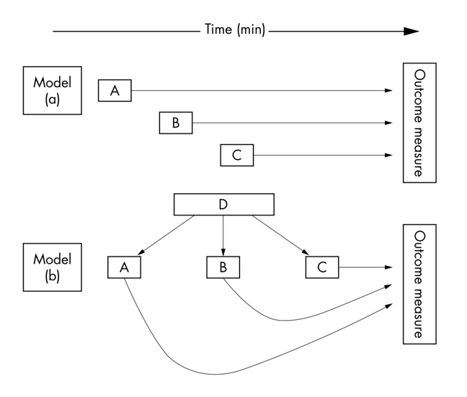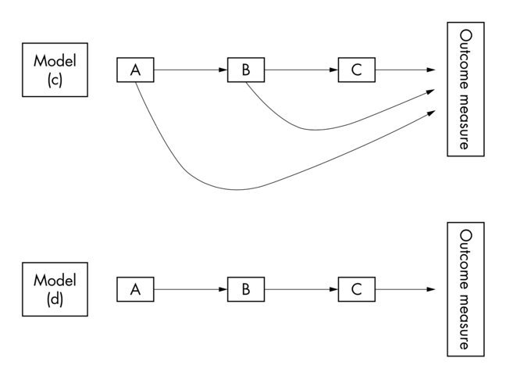

Figure 2: Life course causal models (source:Kuh et al 2003 Glossary p.779)

Earlier life events and conditions have the potential to directly trigger cumulative chain reactions and have persistent indirect effects along the life course, as social institutions act like filters, that grant further advantage or disadvantage based on conditions and experiences of the individual. Every social institution reinforces or even amplifies, rather than alleviates, the effects, that originated earlier in life {ORand:2009vf p.134}.

For example childhood SEP influences educational level, which influences fertility behaviour and household income, which in turn influences disparities in retirement wealth and health (Orand 2009:135). The combination of influential factors can be simply additive or even multiplicative (Pampel & Rogers, 2016)

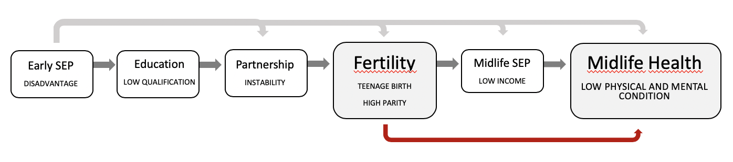

Figure 3 Visualization of a path dependent accumulation model of disadvantage

Both approaches clearly do not cover the whole experience of parenting. One can not say that parents in general are either benefitting from cumulative advantage (like being educated: {Walsemann:2008kf, Mirowsky:2005dk}) or suffering from cumulative disadvantage (like obesity: {Ferraro:2003gm} or race {Shuey:2008ha}), both is the case under certain circumstances. Countless factors accumulate over time, they may interact, intensify or neutralize each other. In certain cohorts in a certain culture and period, certain patterns of associations will manifest across the individual life careers” (frei formuliert – is that true?)

And as newer studies show, the path of accumulation isn’t necessarily a straight line from childhood to adulthood. Factors of chance and personal agency can compensate for disadvantage or else derail advantaged trajectories (ORand, 2009). Illness, divorce and job loss might throw people off their track and bring severe disadvantage in their lives. Occupational mobility, gaining a university degree or starting an exercise routine, even later in life, have the potential to rectify disadvantage (McLeod & Almazan, 2003; ORand, 2009), which brings individual creative power in the focus.

To employ it in this work: parents are exposed to a variety of disadvantages and advantages of having a child or having children from conception until the end of their lives. In long term, children can be seen as risk factors, increasing physical and psychological stress, but also as chances to access well-being, social support and physical health

(see Mayer, 2009, p. 424).

Children can come with certain risks and disadvantages for their parents, like physical and mental stress, narrowed opportunites, role overload, economic costs, disruption of careers and so on {Grundy:2015gz p.111}. Postive Effects: selbe Quelle checken

Obviously the extend of these effects depends on the circumstances like household income, partnership status and parenting history but could it also depend on the number of children? Is having more children more damaging resp. beneficial to the parents?

and advantage?? / compensation

On the other side children also come with health promoting effects and social advantages that are completely ignored in this point of view.

But forms of compensating the accumulation of risk factors are also investigated to check whether the effects are persistent and modifiable (Ferraro).

Ferraro for example found that compemsation for the health disadbanted that resulted from obesity were not manifest through the elimation of the risk factor (weight loss), but rather through lifestyle adjustments (regular exercise) {Ferraro:2003gma}.

A popular theory on aging from biomedicine: wir altern und sterben letztlich weil sici im körper schäden anhaäufen, manches kann der körper nicht selbst heilen und so sammeln sich mit der zeit wird der körper zum wrack

* Hängt zum kleinen teil von den genen ab
* Aber auch zwillinge altern untershciedlich
* Umwelt Und Persönlicher lebensstil (wo und wie du lebst) ist bis zu dreiviertel dafür verantwortlich wie du alterst
* Viel gemüse und wenig kalorien (kraus huffman 2 years of calorie restriction and cardiometabolic risk)
* Sport kann den alzterungsprozess bremsen und teilweise sogar rückgängig machen und das bis ins hohe alter
* Tabak stress und alkohol
* Part oft the optimization trend??

(aus dem srf altern video)

Die Theorie hilft sich die Mechanismen im Hintergrund vorstellen zu können: Eltern sein oder Kinderlos sein bedeutet ganz bestimmte Risiken und Chancen einzugeheen. Unter bestimmten Umständen kommen Risiken oder Chancen eher zum tragen. Im Durchschnitt scheinen sie sich aber, zumindest im aktuellen Deutschland, die Waage zu halten.

Both approaches clearly do not cover the whole experience of parenting. One can not say that parents in general are either benefitting from cumulative advantage (like being educated: {Walsemann:2008kf, Mirowsky:2005dk}) or suffering from cumulative disadvantage (like obesity: {Ferraro:2003gm} race {Shuey:2008ha}), both is the case under certain circumstances. Countless factors accumulate over time, they may interact, intensify or neutralize each other. In certain cohorts in a certain culture and period, certain patterns of associations will manifest across the individual life careers” (frei formuliert – is that true?)

### Summary

SUMMARY PARITY In summary, mechanisms underlying fertility-mortality associ- ations may encompass both selection effects and causal influences, possibly operating differentially for women and men and for those of different socio-economic groups. In some cases mechanisms may be offsetting. For example, high parity among women is associated with higher risks of obesity and possibly with specific cardiovas- cular related effects but also with potentially more social support and social control of health related behaviours. This complexity may explain the divergent results from previous studies and emphasises the need to consider a range of cause groups and both women and men as we do here. Grundy et al 2010

Also results can be very sensitive to the set of control variables.

So Sum Up: Long-term socioeconomic and health conditions are the basis for an guessstimate of the following life course and have a ceratin pulleffect. With Major more or less random events and individual behaviour having the potential to intervene resp. reinforce the “suggested” journey through lifes institutions.

Abschließend ist festzustellen, dass insbesondere Partnerschaften als Verstärker gesundheitlicher Ungleichheit im Lebensverlauf wirken können: Im Einklang zu den Vorhersagen des soziologischen Ressourcenmodells tragen (glückliche) Paarbe- ziehungen zu einer Akkumulation gesundheitsrelevanter Ressourcen bei (positiver Kausaleffekt). Gleichzeitig kommen typischerweise vor allem solche Personen in den Genuss partnerschaftlicher Bindungen, die bereits ex ante eine bessere Ressour- cenausstattung aufweisen (Positivselektion). Insgesamt kann dadurch möglicher- weise eine sich selbst verstärkende Dynamik gesundheitlicher Kumulationseffekte in Gang gesetzt werden, die zu einer zunehmenden gesundheitlichen Ungleichheit im Lebensverlauf beiträgt. In Bezug auf Elternschaft scheinen ähnliche Prozesse wirksam zu sein, wobei jedoch z. T. gegenläufige Mechanismen (Negativselektion früher bzw. höherer Fertilität bei bestimmten ungünstigen Gesundheitsmerkmalen) sowie moderierende Rahmenbedingungen (z. B. Alter bei der ersten Geburt) die Komplexität des Zusammenhangs erhöhen. Auch durch die in der Regel lebenslan- gen Solidarbeziehungen von Kindern gegenüber ihren Eltern hat Elternschaft häufig positive langfristige Konsequenzen für die elterliche Gesundheit, zukünftige For- schung sollte jedoch hierzu verstärkt die potentiell moderierende Rolle der Qualität von Generationenbeziehungen fokussieren. Insgesamt besteht trotz umfangreicher empirischer Evidenz weiterer dringender Forschungsbedarf zur kausalen Wirkrich- tung und zu den mediierenden Mechanismen. Querschnittstudien, die bislang auf diesem Forschungsgebiet vorherrschen, sind methodisch nicht in der Lage, adäquat mit durch Selektions- und Kausalitätseffekte entstehenden Herausforderungen umzugehen. Die vergleichsweise wenigen Panelstudien, über die wir im vorliegen- den Beitrag berichten, sind jedenfalls ein guter Anfang, um mehr Klarheit in die Erklärung der komplexen Zusammenhänge zwischen Partnerschaft, Elternschaft und Gesundheit zu bringen. Als ein mögliches und geeignetes Analyseinstrument erscheinen (FE-)Panelanalysen, die sowohl zeitkonstante unbeobachtete Heteroge- nität als auch partiell Selektionseffekte kontrollieren können.

BECKER 2017

# Aims and Hypotheses

With regard to midlife health outcomes in Germany the dataset will be approached with the following questions:

Q1: Is Parenthood in general better than having children?

Q3: Which is the optimum age for having a first child?

Q2: Which number of children is optimum?

Q5: Are women’s and men’s health affected differently by their fertility patterns?

Q6: Are physical and mental health affected differently by fertility patterns?

Based on the previous literature and given the control variables mentioned below, the hypotheses are:

H1: Childlessness is generally associated with worse physical and mental health compared to parenthood.

H2: Early-first-birth-parents have generally poorer physical and mental health outcomes than parents who had their first child later in life.

H3: The optimum age for first birth is around the age of 30. For men the optimum age might be a bit higher, for women a bit lower.

H2: Among parents, having 1 or 4+ children is associated with worse physical and mental health outcomes compared to having 2 or 3 children.

H5: Women are generally affected more by their fertility history than men (positive and negative) due to the higher physical and social involment.

H6: Mental health might be affected more by short term effects (like having a small child) than physical health OR Physical and mental Health are affected similarly, since both highly correlate with each other.

# Data and Measures

## Data and Sample Description

The German Panel Analysis of Intimate Relationships and Family Dynamics *pairfam* provides data on the formation and development of intimate relationships and families in Germany. In 2008/09 the panel multi-actor survey started with a random sample of all german-speaking persons living in private households from the population register. Three age cohorts have been selected for the survey (cohort 1: 1991-93 aged 15-17, cohort 2: 1981-83 aged 25-27, cohort 3: 1971-73 aged 35-37 in 2008). One hour CAPI-interviews are repeated annually with minor changes in the survey design. The study is funded by the German Research Foundation (DFG) until 2022 (Brüderl et al., n.d., p. 1).

Beginning with wave five (in 2012/13) the East German panel *DemoDiff* was integrated into *pairfam* which resulted in an overrepresentation of East German residents in the sample. Therefore, special weights are to be used in the analysis (Brüderl et al., n.d., pp. 2f.) (for more details, see the pairfam Data Manual).

To control external validity pairfam data is compared to other german high quality studies like the German Family Survey, Mikrozensus and SOEP (Brüderl et al., n.d., p. 25ff.). This showed a general coherence and indicates the external validity of the surveys. On certain parts the pairfam data showed even more plausible results and seems to outperform other studies (Brüderl et al., n.d., p. 28).

This paper is using Pairfam wave seven material, collected in 2014/2015 and will focus on the oldest cohort, born 1971-73, i.e. aged 40 to 44 (*M*=42.11, *SD*=.86) at the time of the questionnaire. At this age it can be assumed that the large majority of people has terminated their fertility history as a birth after 40 years of age is relatively seldom, especially for women {Destatis:2012uh p.28}. Looking into the data, five percent think that having additional children is a realistic scenario (1.96 percent of women and 9.39 percent of men).

## Measuring Health

In a general perception “health can be defined negatively, as the absence of illness, functionally, as the ability to cope with everyday activities, or positively, as fitness and well-being” {Blaxter:2005vo p.14}. The World Health Organization WHO defines health as “a state of complete physical, mental and social well-being and not merely the absence of disease or infirmity“ {WHOWorldHealthOrganization:1946tc p.1}.

To conceptualize {see Waller:2006wx p. 9 f;, Blaxter:2005vo p. 2 ff} and measure health, a number of standardized tools has been developed (see McDonnell and Newell 2006, esp. P. 520ff.) such as scales of depression, chronic disease, self-rated health, well-being, cognitive ability and others (sagt Mayer 422). This Paper will work with the self-reported Short-Form-12 Health Survey Version 2 (SF12v2), an internationally applied, but Germany-specified health score.

Mental Health and physical health have a bidirectional and complex relationship: poor mental health is a risk factor for chronic physical illness. Vice versa chronic physical conditions are a risk factor for poor mental health. To give just a few examples: The rates of depression among US citizens with diabetes are two times greater than in the general population and both diseases seem to act as a cause for the other: “Just as type 2 diabetes increases the risk for on-set of major depression, a major depressive disorder signals increased risk for onset of type 2 diabetes” {Ducat:2014fs p.691}. Negative emotions, and especially anxiety, also promote the development of coronary heart disease {Kubzansky:2000ka}. And there is a 30% higher mortality from cancer among psychiatric patients than in the general population, even though their incidence is the same or even lower {Kisely:2013dc}.

Having to deal with a severe illness comes with disease burden and stress, feelings of being overwhelmed, concerned and guilty. Yet mental issues are associated with poor self-care, late diagnosis, higher rates in treatment drop-outs, complication and work disability {Ducat:2014fs p.691}.

This paper looks at both health dimensions separately, using self-reported non-cause-specific health scales. Therefore we won’t be able to look at certain illnesses but more at health in a general way, consistent with the health definitions above.

### The Short Form SF12v2 Health Survey

RAND Corporation developed the 12 items SF-12 on the basis of the original 36 items survey using an 1998 U.S. norm sample. SF-12 was designed to be brief and therefore of practical use in large-scale surveys, i.e. it fits on one single page and is administered in two to three minutes. Still, it covers the same dimension as the original SF-36 and reproduces 90% of its variance {:1996tf p.666}. (Ware 1996: 666) Being a very short and still reliable version of SF-36, it is a remarkably effective and internationally applied measure of overall health {Andersen:2007ui p.171}.

The German Socio–Economic Panel SOEP has developed and adapted the SF-12v2 questions specifically for the German population

{Andersen:2007ui p. 172, Nubling:2006ua p. 2}. This German survey version is included in the Pairfam panel every other year from wave 7 on.

The short form measures eight health dimensions with 1-2 items each. These dimension add up to two main constructs resp. sum scores on a zero to 100 scale: physical health composite score (PCS) and mental health composite score (MCS).

The eight dimensions are being covered by questions concerning pain, fitness and well-being but also social functioning. For each question three to five answering possibilities are given. Please look at the variables list in the attachment of this paper for the exact wording of the questions (Anhang XX, Page XX). Using the SF-12v2 it will not be possible to address specific diseases and health issues, but only general physical and mental health.

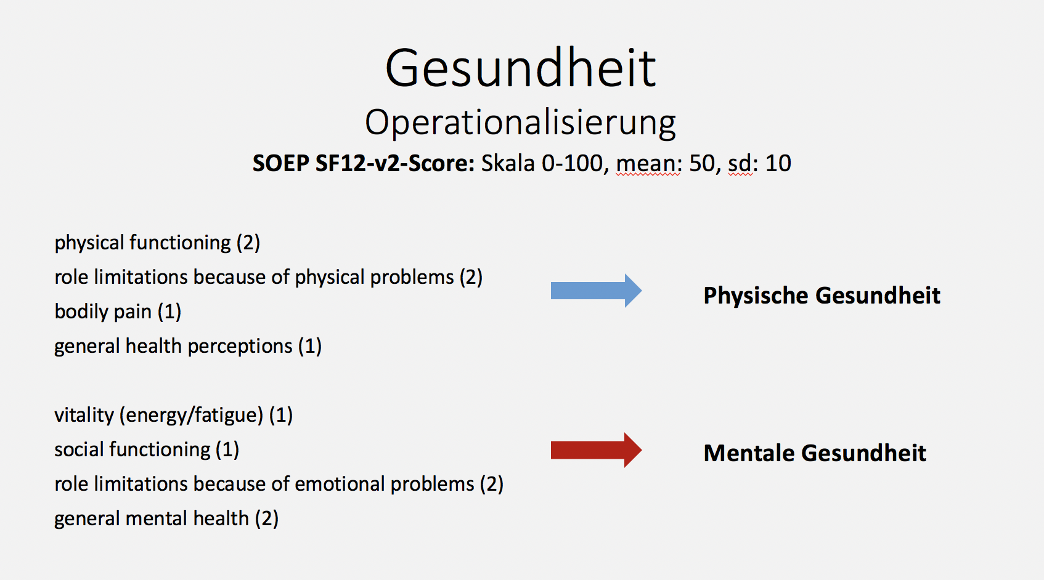

12 Item, 8 dimension, 2 Scales/Index, 1 Sum Score?

### Calculating the Health Scores (Norm-Based-Scoring)

To generate two indices from the twelve items and eight dimension, I followed the recommendation of the German SOEP

{Nubling:2006ua, Andersen:2007ui}. Although SOEP is one of the largest representative German surveys (over 20,000 cases) and claims to offer a German norm sample and reference values for all further surveys using the SF-12v2 questionnaire {Andersen:2007ui p.171}, the first step of this analysis was to employ the algorithm on the pairfam sample (wave 7, cohort 3, n=2117) and check whether the two health dimensions can be clearly obtained from this dataset.

Only cases that provided valid answers for all 12 items are included in the computation. The missing values per variable amounted from 0 to 0.8 percent; Almost 99 percent of cases did not show any missings, so that 1.35 percent (29 of 2146) cases have been excluded. The overall impact of missing values on the sample is negligible.

The scales of seven items were inverted so that increasing values stand for increasing health perceptions and in four cases, where one dimension contained two items, a sum scale has been calculated. The resulting eight health subscales have then been standardized to a range from 0 to 100 (see means and sd in table xx below).

(sum gh pp pf pr vt sf mh mr)

Variable Obs Mean Std. Dev. Min Max

pf 2117 82.83 25.97 0 100

pr 2117 86.24 22.06 0 100

pp 2117 84.46 24.33 0 100

gh 2117 64.32 23.85 0 100

vt 2117 51.67 24.40 0 100

sf 2117 91.53 20.02 0 100

mr 2117 92.32 18.11 1 100

mh 2117 71.27 20.50 1 100

With exploratory factor analysis it is to be investigated, whether the eight subscales clearly depict two latent factors for mental and physical health and therefore can be reasonably summarized.

(While principal factor analysis suggested 3 ambiguous factors, principal component factor ananlysis confirms the idea of the two factors.)

Unrotierte factor analysis PCF unrotated principal component factor analysis shows two factors with Eigenvalues over 1, meaning that they explain more than one single variable, and that they clarify together about 62% variance. All variables load high on the first factor, which confirms their common features {Wolf:2010fj p.344}, since it cannot be assumed that mental and physical health are completely independent dimenions. Some also load high on the second factor: so content wise the two suggested factors can not be reasonably interpreted as physical OR mental health related.

To allow a content related interpretation of the two factors, the koordinatensystem of variables and factors needs to be rotated in a way that every variable loads highly on one specific factor, but not on the other. We can either rotate orthogonal or oblique. Both possibilities were explored:

Orthogonal Varimax PCF (Varimaxaz maximierend, 90Grad, Orthogonal wird rotiert wenn man unabhängige Faktoren beibehalten möchte) rotation was applied I found a clear pattern of four highly loading variables (0.6 – 0.8) per factor in two categories: which can be interpreted as mental (vitality, social functioning, role limitations due to emotional problems and general mental health) and physical health (physical pain, role limitations due to physical problems, physical functioning, general health) – just like suggested by the SF-12v2 instructions.

The Uniqueness (over 0.5) / Kommunalität (under0.6) of vitality is not satisfying, all other variables are good.

Oblique Oblimin PCF (korrelierende Faktoren) rotation was applied, with similar, slightly better outcomes. Since it is to be assumed that both factors are indeed not independent from each other – being two dimensions of one concept – we will work with the factor charges of oblimin rotation in further calculations i.e. calculate the final aggregate scores hpcs and hmcs using these factor score coefficients.

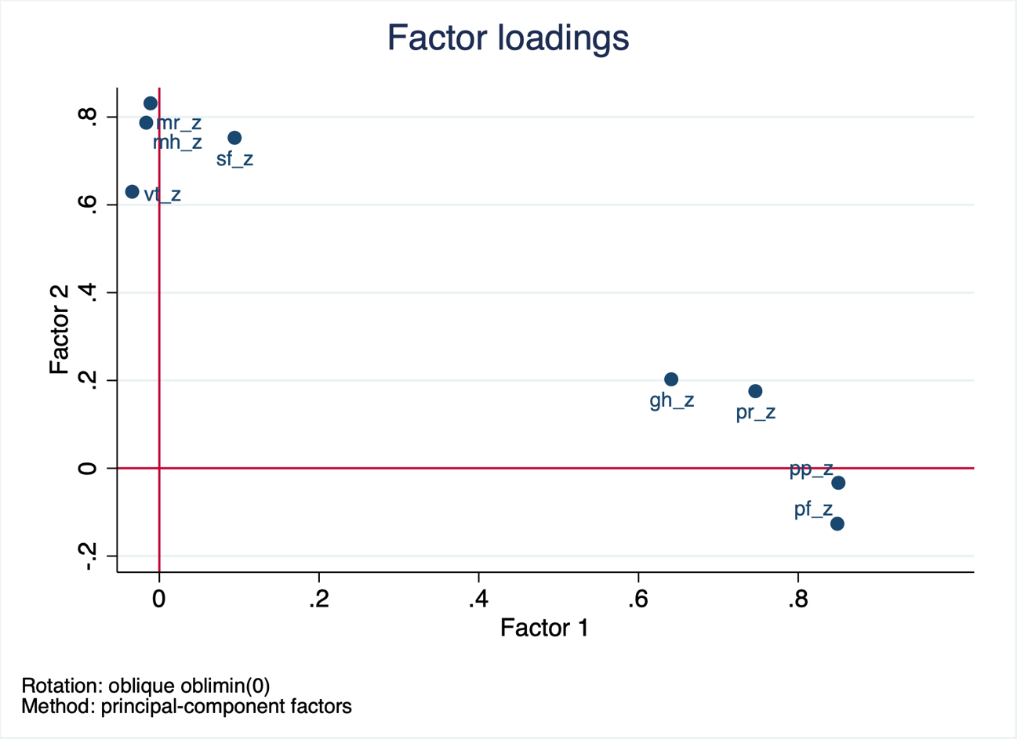

Kaiser-Meyer-Olkin Kriterium (KMO) showed high values of 0.79-0.89, overall value of 0,85 (meritorious) for the variables, which confirms their eligibility for pcf (wolf, Dziuban & Shirkey (1974).

After another scale transformation to a mean of 50 and standard deviation of 10±. The norm-based-scoring process is complete and the distribution table looks like this:

Variable | Obs Mean Std. Dev. Min Max

-------------+--------------------------------------------------------

hpcs | 2116 50.01021 9.991326 7.737961 62.10843

pcs | 2116 48.1491 10.88766 .4837561 68.91058

hmcs | 2116 49.99982 10.00236 -1.373377 64.98676

mcs | 2116 50.47297 10.22301 .0534296 69.87804

the scale 0-100 is lost!

An empirical value of 50 exactly equals the mean health value of pairfam wave 7, cohort 3 (.e. a value of 50 is equivalent to average health), a value of 40 would mean that it lies one standard deviation below the mean value {Andersen:2007ui p.176} The empirical Minimum lies between minus one and seven, the Maximum between 62 and 65.

Because norm scores were used, the mean score for both physical and mental health lay at around 50 (physical health: *M*=50.01, *SD*=9.99, mental health: *M*=49.99, *SD*=10.00). With regards to physical health, the smallest measured value was 7.74 and the maximum score lay at 62.10). For mental health the minimum was -1.37 and the maximum was 64.99, showing a wider range and for some reason even some negative values. The health outcomes for men and women were relatively similar, with a slightly better mean score for men on both scales.

After excluding cases with missing values in the variables of interest and implausible data we end up with 2,116 observations (56 percent female, 44 percent male).

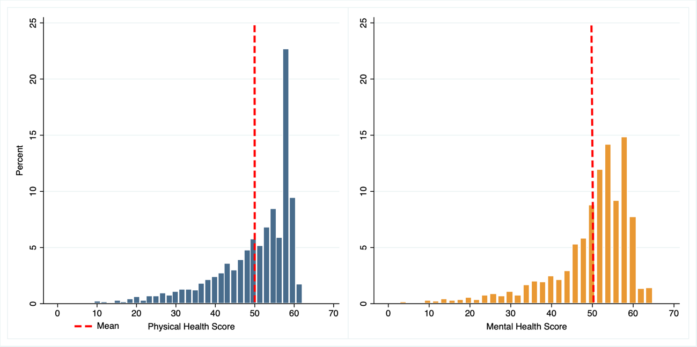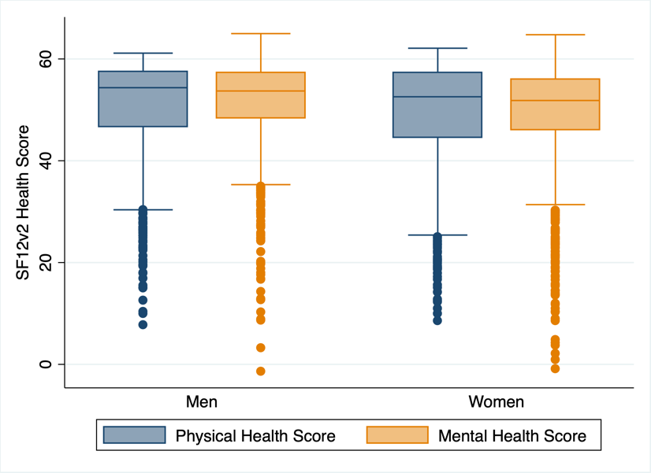

Figure 4: Distribution of Physical and Mental Health Scores

## Measuring Fertility

In this paper Fertility is conceptualised in three factors: Parenthood vs. childlessness, age at first birth, and parity i.e. the number of children.

Parenthood

Every repsondent who indicated to have at least one living child, no matter whether biological, step, or foster, is classified as a parent. Therefore the sample consists of 1,745 (82.5%) parents and 371 (17.5%) childless. Compared to the general population of Germany, women and parents are distinctly overrepresented in this dataset.

All together 3,661 children are part of the analysis, of which 189 are non-biological children to the respondent (i.e. adopted, foster and step children). Deceased children and their parents are excluded from the analysis.

In an attempt to narrow down ‘active’ from ‘passive’ parents, I created variables to compare parents, who currently share a household with at least one child or least one biological child with the childless.

Parent’s Age at Birth of their first Child

To compare age at first birth, dichotomous dummy variables for five age groups were created. For reasonable group size, early first birth is defined as having had the first child up until age 22 for women and men. Late first birth would be a first birth at age 35 or later. The sample average age at first birth lies at 28.55 (*SD*=5.51, *min*=13, *max*=43), more specifically at 27.55 for women and 29.96 for men.

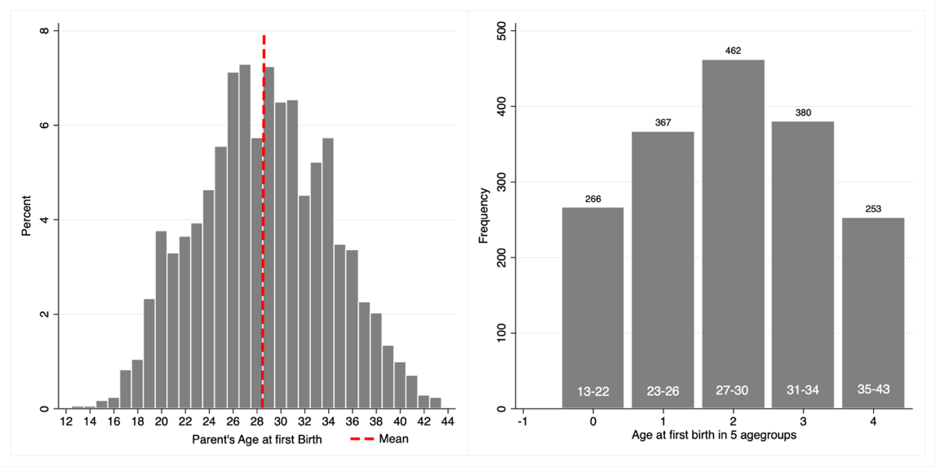

Figure 5: Distribution of Parent's Age at first Birth

Parity

On average every anchor has 1.73 (*SD*=1.2, *min*=0, *max*=10) kids. Looking at parents only, the mean number of kids is 2.*1* (*SD*=.99). Due to small frequencies at high parity, all cases of 4 or more kids were grouped into one.

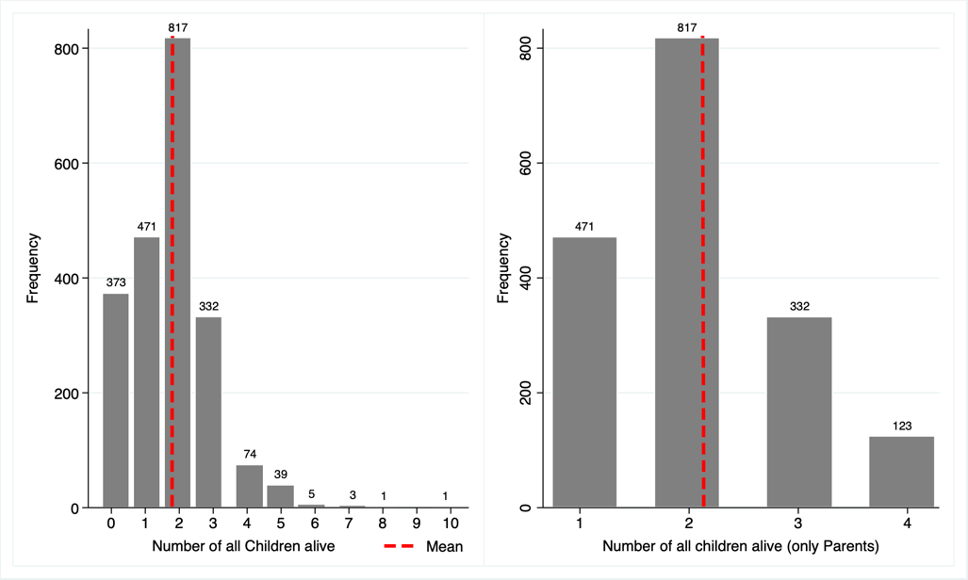

Figure 6: Parity per Respondent / Pyrity per Parent

For an alternate measure of parity or ‘parenting intensity’, I calculated the sum of cohabiting years per parent, that is adding together all the years that the responded cohabited with every single one of their children. A person who actually has kids, but never lived with any of them, would end up with 0 cohabiting years; childless individuals are not included in the scale. The idea behind this is, that all the costs and benefits of having children only come into play when the parent is actually exposed to their child(ren) on an everyday basis.

## Covariables

Based on the current state of research and the available items in the pairfam questionnaire, a set of covariables was operationalized to control for moderating factors.

Parent Stress

The Pairfam questionnaire asked Parents about their problems and worries with rearing children. I used ten items to summarize a parent-stress score, including topics like feeling pressured, insufficient, overburdened, or anxious as a parent. Subsequently a dummy was created to differentiate those parents with above average stress levels (about 44 percent of fathers and 48 percent of mothers) from the others.

Support for Parents

The parent respondents were asked to what extent they feel supported in their parent role by their partner and by other family members and friends. Two dummys were created with ‘1’ for above average support scores. Another variable measures the overall satisfaction with the childcare situation. Since it was originally operationalized using a 10 item Likert scale, I calculated the average satisfaction over all parents’ children and treat it as a quasi interval scale.

Breastfeeding

As described above, breastfeeding is supposed to be health protective for women. A dummy was created to control for people who had breastfed at least one of their children. Only parents who had an infant or toddler at the time of the interview in 2014/15 were asked this question, so only 144 cases could be identified.

Interestingly, a good deal more men than women answered the question, leaving us with 91 men and 53 women, who had at least one child breastfed themselves or by their partner.

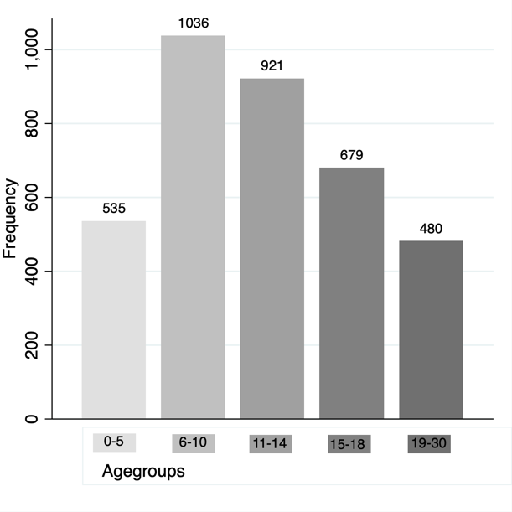Age of children

To isolate the effect that very young children or adult children might have on health, five dichotomous variables were created to indicate whether a parent has at least one child in a given age group. For rea-sonable group sizes I chose the segmentation as follows: 0-5 years (babies, toddlers, pre-school kids), 6-10 (elementary school), 11-14 (young teenagers), 15-18 (adoles-cents), 19-30 (adults).

Figure 7:Number of Children per Age Group Overall

Relationship Status

Relationship status was dichotomized into married and/or cohabiting respondents vs. single, divorced, or living-apart-together respondents (66 vs. 34 percent). As an alternative measure of relationship stability, the duration of the current relationship in years was summed up (*mean*=15.2, *SD=*7.5 *min*=0, *max*=29).

Education

To represent the level of education I use the sum of education Years (*mean*=13.6, *SD=*3.0 *min*=8, *max*=20) and a dummy variable to identify those with higher tertiary qualification (30 Percent) from the others.

Occupation

A dummy distinguishes employed individuals (full time, half time, self-employed) from other (marginally employed, unemployed, retired, stay at home). 81 Percent of the sample participates in professional life on a substantial and regular basis.

Finances

The respondents’ financial position was measured by their monthly househould net income (excluding nine outliers of very high incomes above 12,000 Euro monthly) and by a dichotomous variable that indicates whether someone has experienced serious financial hardship in their life. The mean household income is widely spread with a mean at 3,300 Euro (*SD=*1,612 *min*=0, *max*=12,000). About 22 Percent had experienced big financial problems like dept and insolvency before.

East / West Germany

Another dummy is to indicate citizens of the former Eastern States of Germany. With 34 percent they are heavily overrepresented in the Sample, presenting only 15 Percent of Germanys total population. Since this paper is not predicting future health outcomes, but rather analyzing possible causal effects for past events, I keep the Sample as is.

Smoking

A Dummy Variable indicates whether somebody currently is an active smoker (about 30% of the interviewed). A continuous variable shows the intensity of smoking, i.e. the number of cigarettes, pipes, or cigars smoked per day. For active smokers a daily average of 14.5 was found (*SD*=9, *min*=0, *max*=60).

Alcohol

In a similar way drinking alcohol was dichotomized to differentiate regular drinkers (3 times per week or more: 17 percent of respondents) from occasional drinkers (1 to 2 times per week or less: 83 percent). A continuous variable tells how often an active drinker had more than five alcoholic drinks on one occasion in the preceding month, and therefore displays the intensity of their drinking (*mean=1.5, SD=*1.9, *min*=0, *max*=6).

Sport

A dummy indicates whether a person exercises at least once per week on a regular basis. 973 of 2,115 cases (i.e. 46 percent) do.

Social Contacts

Seeing friends was dichotomized to check whether a person is having social contacts at least once per week (816 people, 39 percent do).

Sleeping

Another dummy variable helps to identify people who get a good amount of sleep of 6 to 8 hours on a working day night (about 85 percent do). Sleeping shorter or longer hours was both associated with worse health outcomes, especially for physical health.

Overweight

Since data on height was missing, the respondents’ body mass index could not be calculated. As a workaround I split the panel up into four same size groups along the weight variable and used the upper quartile to check for overweight and obesity with a dummy. This concludes women weighing 80 to 140kg (289 observations) and men weighing 95 to 165kg (255 obs.)

Prior Health

The categorical scale for the respondents childhood health was dichotomized to distinguish people who had good or very good health during their own childhood from the others (83 vs 17 percent).

## Variables and Correlations Overview

For a first overview of the data, the health score means of all categorial variables as described above, are depicted in Figure 8.

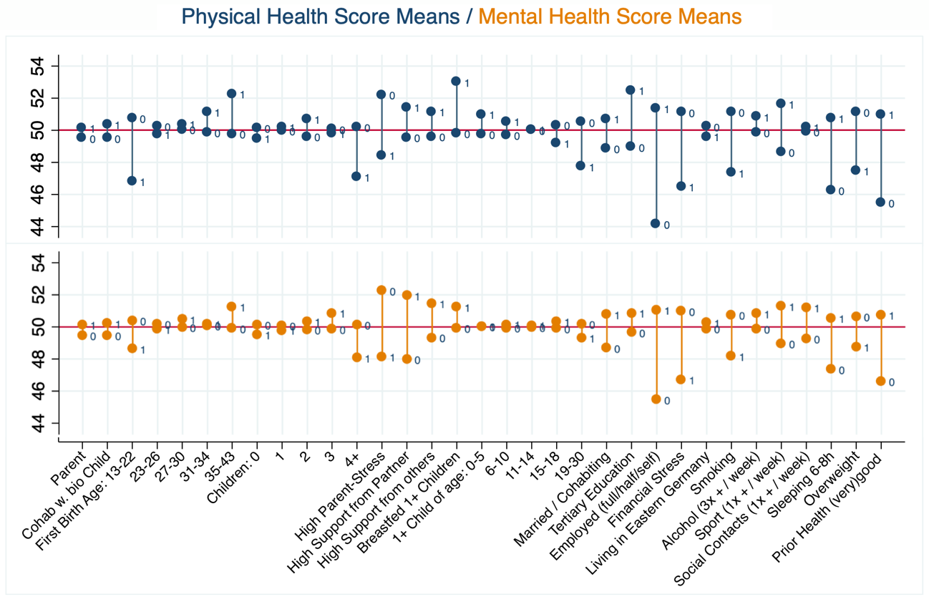

Figure 8: Health Score Means of all categorical independent Variables (physical health on top, mental health below)

Overall the effects seem to be stronger on physical health, than on mental health but all associations point in the same direction for both scales.

At first glance parenthood as such does not seem to be a decisive health factor, but early and late first birth, as well as having more than three children appear indeed to be associated health outcomes.

Furthermore I investigated the correlation coefficients and significance levels between all operationalized dependent and independent variables to weed out unsignificant factors, choose between variables if there were two measuring the same concept and trying to avoid multicollinearity from the get-go. Figure 9 shows the pairwise correlation coefficients of the health scores and selected covariables.

Having child(ren) of the oldest age group is stronger associated with health than having children in any other age group. Bu as children’s age groups are strongly correlated with age at first birth and statistically insignificant for mental health they are mostly redundant.

Breastfeeding was only associated with physical health, but, and this is though-provoking, shows similar health associations for men and women.

The dummy for ‘married and/or cohabiting’ appears to be a stronger health predictor than ‘current relationship duration’, that’s why I chose to drop the latter.

For education however, the continuous variable ‘years of education’ proved to be stronger than the dichotomized variable that differentiated between university graduates and others.

The number of smoked cigarettes and cigars per day (scale containing 0 for non-smokers) was stronger correlated with health outcomes than the dummy of ‘smokers vs. non-smokers’.

Maintaining social contacts proofed to be relevant for mental health, not so for physical health.

Consuming alcohol and living in Eastern or Western Germany were not found to be relevant for further analysis.

The correlations are generally not very strong with the strongest coefficient being 0.37 for household income and years of education.

Having said that, occupational status, parent-stress and prior health conditions seem to be relatively important health predictors. For physical health lifestyle factors play a big role, for mental health it is rather the support from a partner and childcare services that make a difference.

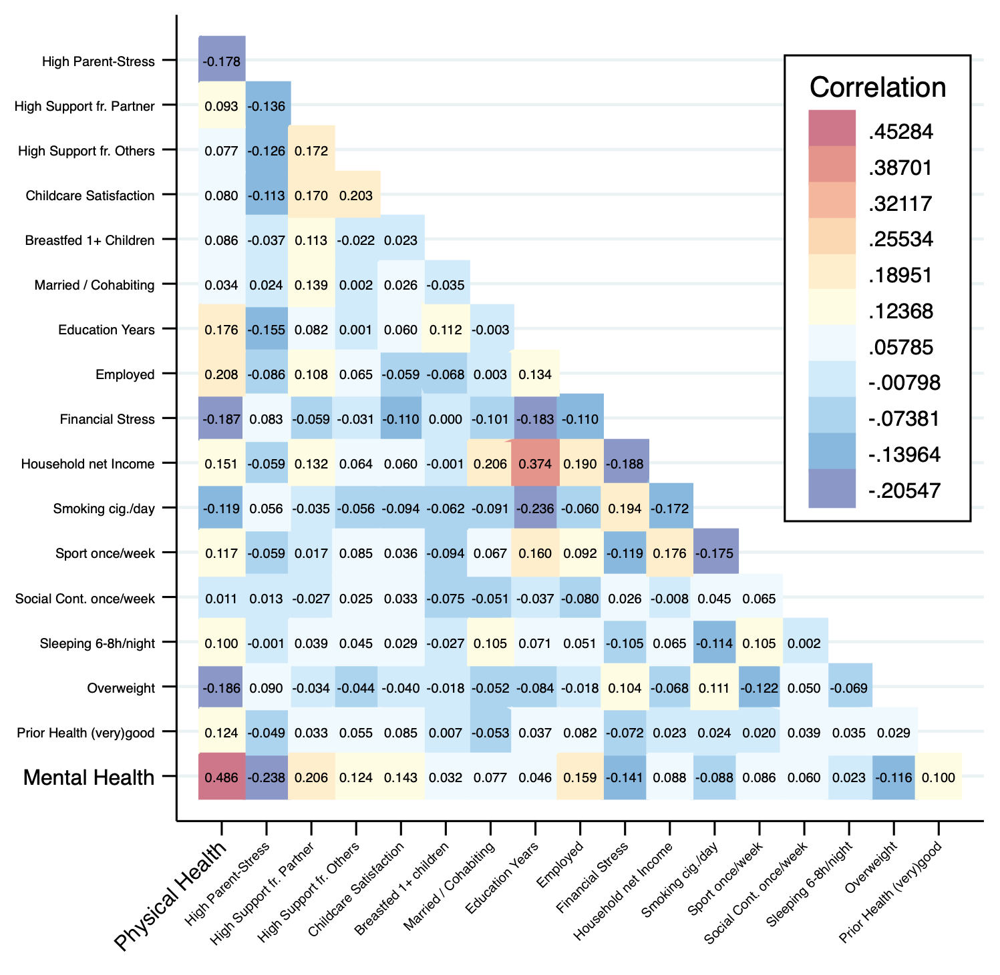

Figure 9: Correlation Heatmap - Health Scores and Covariables

In Table 10 the differences for men and women are broken down: Women’s mental health seems to be more negatively affected by parenting stress, but also more positively affected by the support of their partner.

Being married, being employed and excercising has a distinctly stronger positive effect on men’s physical and mental health than on women’s.

Overweight and prior health conditions are more relevant for women’s health outcomes than for men’s.

|  |  |  |  |  |
| --- | --- | --- | --- | --- |
|  | Physical Health | | Mental health | |
|  | Women | Men | Women | Men |
| **Fertility Predictors** |  |  |  |  |
| Being a Parent | 0.03 | 0.04 | 0.02 | 0.06 |
| Cohab 1+ bio Child | 0.03 | 0.06 | 0.02 | 0.08* |
| Age at first Birth |  |  |  |  |
| 13 - 22 | -0.17*** | -0.07 | -0.04 | -0.08* |
| 23 - 26 | 0.04 | -0.10** | 0.00 | -0.03 |
| 27 - 30 | 0.02 | 0.00 | 0.03 | 0.02 |
| 31 - 34 | 0.06* | 0.03 | -0.02 | 0.02 |
| 35 - 43 | 0.05 | 0.11** | 0.03 | 0.04 |
| Number of Children |  |  |  |  |
| 0 | -0.03 | -0.04 | -0.01 | -0.05 |
| 1 | 0.01 | 0.01 | -0.02 | 0.01 |
| 2 | 0.03 | 0.08** | -0.00 | 0.08* |
| 3 | -0.00 | -0.01 | 0.04 | 0.04 |
| 4+ | -0.04 | -0.11*** | 0.00 | -0.12*** |
| Cohabition Years | -0.09** | -0.04 | 0.03 | -0.01 |
| **Parenting Factors** |  |  |  |  |
| High Parent-Stress | -0.20*** | -0.18*** | -0.23*** | -0.18*** |
| High Support from Partner | 0.07 | 0.10* | 0.22*** | 0.12** |
| High Support from others | 0.05 | 0.11** | 0.11*** | 0.12** |
| Childcare Satisfaction | 0.10** | 0.14*** | 0.16*** | 0.16*** |
| Breastfed 1+ Children | 0.07* | 0.08* | 0.03 | 0.03 |
| **Lifestyle Factors** |  |  |  |  |
| Married and/or Cohabiting | 0.06* | 0.12*** | 0.08** | 0.13*** |
| Education Years | 0.18*** | 0.21*** | 0.08** | 0.05 |
| Employed (full / half / self) | 0.23*** | 0.37*** | 0.18*** | 0.27*** |
| Financial Stress | -0.19*** | -0.20*** | -0.14*** | -0.23*** |
| Household net Income | 0.20*** | 0.25*** | 0.11*** | 0.18*** |
| Smoking: cigarettes per day | -0.17*** | -0.24*** | -0.17*** | -0.13*** |
| Sport: at least once per week | 0.12*** | 0.20*** | 0.09** | 0.17*** |
| Social contacts: once / week | 0.03 | -0.01 | 0.11*** | 0.08* |
| Sleeping: 6-8h per night | 0.15*** | 0.19*** | 0.09** | 0.16*** |
| **Health Factors** |  |  |  |  |
| Overweight | -0.22*** | -0.10** | -0.11*** | -0.06 |
| Prior Health: (very) good | 0.27*** | 0.12*** | 0.17*** | 0.12*** |
| Observations | 1187 | 929 | 1187 | 929 |

Figure 10: Correlation Overview – all Variables  * p < 0.05, ** p < 0.01, *** p < 0.001

# Analysis

Having child(ren) of the oldest age group is stronger associated with health than having children in any other age group. Investigating the correlation coefficients and significance levels it becomes apparent that children’s age groups (especially group 1 and 5) affect physical health but are completely insignificant for mental health.

Surprisingly having child(ren) of the oldest age group is stronger and negatively associated with health than having children in any other agegroups. This contradicts the idea that especially babies and toddlers take their toll on parents health by depriving them of sleep and control, and that adult children could act as a source of support for their parents.

## Are Parents generally healthier than the childless?

To start the analysis, we assume that childlessness is generally associated with worse health compared to having one or more children. A comparison of the mean health outcomes indeed indicates, that parents have a slightly better physical (.62 higher) and mental health (.67 higher) than non-parents.

When differences between independent groups (nominal) are to be investigated in relation to a metric variable, a recommended method is the two-sample t-test with equal variances (physical health) resp. unequal variances (mental health). While the t-test premise of normally distributed health attributes within the samples was admittedly not given, as a Shapiro-Wilk-Test showed, the results were yet confirmed by an additional non-parametric test Mann-Whitney-U-Test (*Z*=-1.262, *p*=.21 and *Z*=-.17, *p*=.85).

The results however, show no statistically significant differences between parents and non-parents for physical health (*t*(2114)=-1.09, *p*=.28) and for mental health (*t*(499.63)=-1.07, *p*=.28) as a XX test has shown.

Another attempt to detect health differences, was to more precisely define the parent group. Simply having a child might not equal being a ‘real’ parent. If parentship means actually being exposed to all the effects that children can have on them, some sort of parenting and cohabitation with a child should be given. Based on these thoughts parents who actually have lived with at least one child in their main residence were compared to childless people – excluding 120 parents who never cohabitated with a child. This test showed just as little significant results as the first comparison.

In a last attempt, parents who actually have lived with at least one biological child were compared to the childless people – excluding another 115 parents. This test was based on the idea that biological children might have stronger impacts on their parent’s health than step, foster or adopted children. Especially step and foster children tend to occur in their parent’s life only some years after birth and therefore the physical and mental impacts might not be as strong. This test also didn’t show any significant differences, and the mean values of all groups were very much the same. These results lead to the conclusion that the slightly better health outcomes in the group of parents probably are coincidental and of no practical and statistical significance.

|  |  |  |  |  |  |  |
| --- | --- | --- | --- | --- | --- | --- |
| **Physical Health** | ***Mean*** | ***SD*** |  | **Mental Health** | ***Mean*** | ***SD*** |
| Childless | 49.50 | .53 |  | Childless | 49.45 | .57 |
| Parents | 50.12 | .24 |  | Parents | 50.12 | .23 |
| Cohabiting Parents | 50.34 | .24 |  | Cohabiting Parents | 50.30 | .24 |
| Cohabiting Bio Parents | 50.35 | .25 |  | Cohabiting Bio Parents | 50.20 | .25 |

## What is the optimum number of kids?

The second Hypothesis says that having two or three children is generally associated with better physical and mental health outcomes than having no, less, or more than three children. The distribution scores of physical and mental health should presumably resemble an inverted U-shape, meaning that persons with no or few children should have low scores, persons with more children should have comparatively higher scores, and persons with yet more children should have lower scores.

From five kids on, the number of cases becomes vanishingly small. For this reason, all the parents of five or more children were pooled into one group. All in, a total number of six groups, ranging from zero children to five or more children, were looked at. Change to 4+!



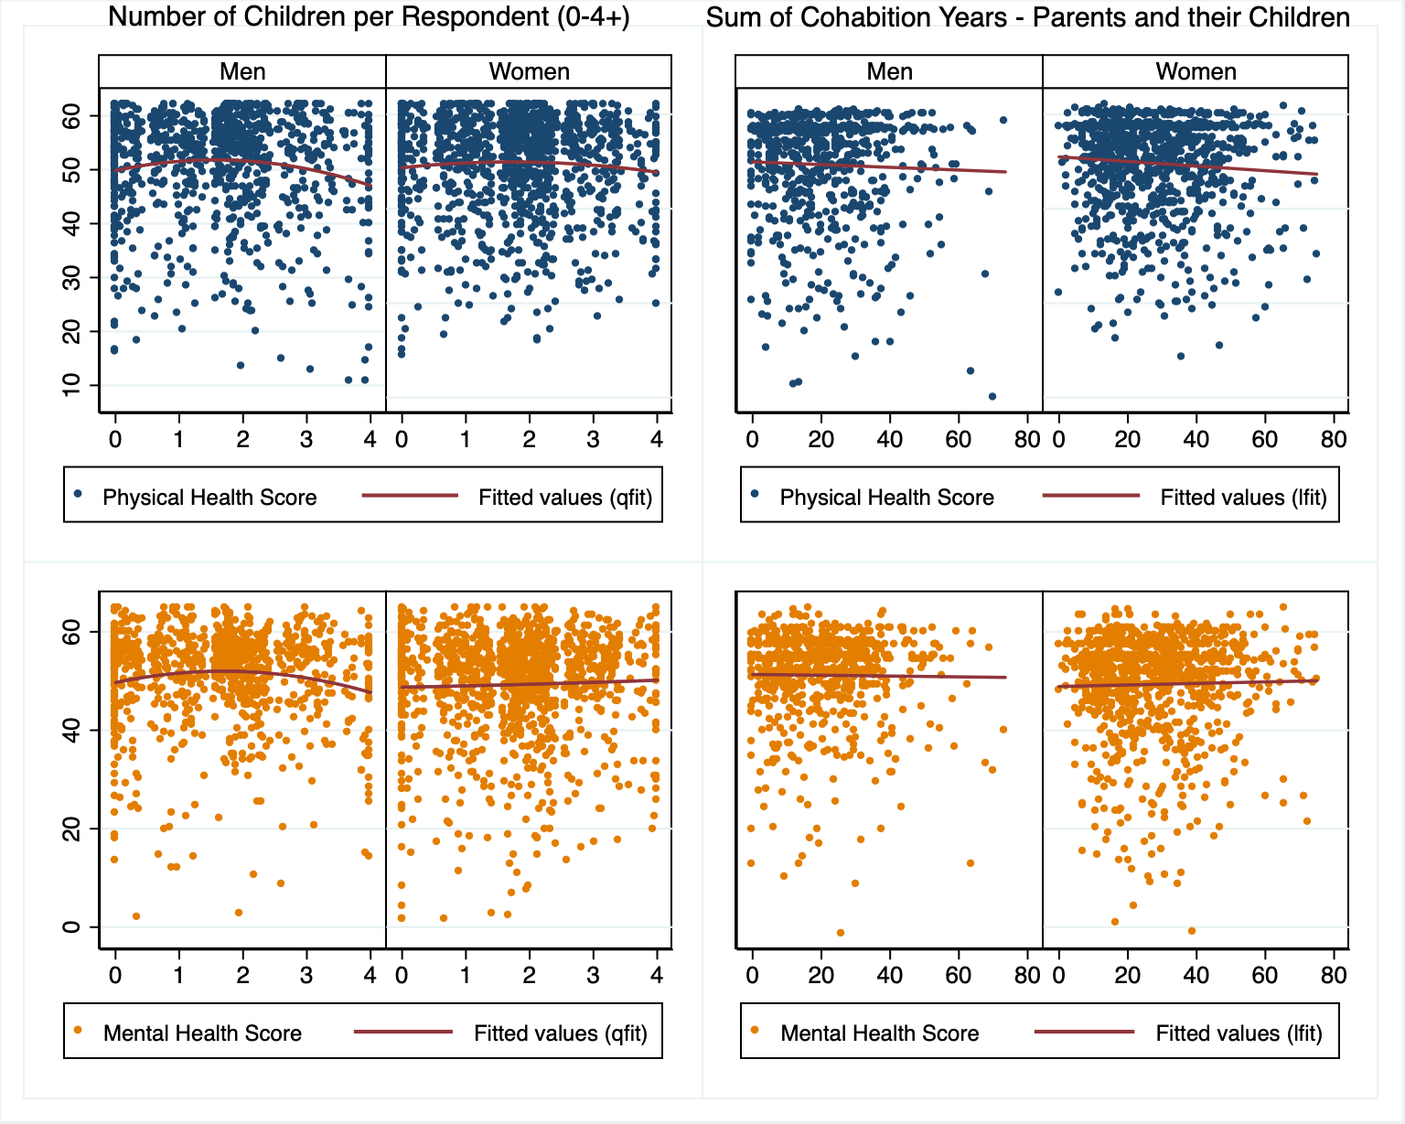

Since the predictor ‘number of kids’ is not an interval scale, as long as it includes zero for ‘childless’, we begin with an one-way analysis of variance (forthwith referred to as ANOVA). ANOVA does what the t-test did, but for more than two groups: comparing the differences in the health mean values for independent samples.

Shapiro-Wilk-tests showed that all groups deviated from normal distributions in regard to physical and mental health (each *p*<.001). Besides, variance heterogeneity for both health scales (*p*<.001) were found. Considering that, two one-way ANOVAs, as well as their non parametric equivalent, two Kruskal-Wallis-Tests were conducted. ANOVA showed a significant difference between the groups in regard to physical health (*F*(5,2110)=3.11, *p*=.009), but not so in regard to mental health (*F*(5,2110)=1.84, *p* =.1). The subsequently conducted Kruskal-Wallis-Tests confirmed these results for physical health (*p*=.043) and mental health (*p*=.345).

|  |  |  |  |  |  |
| --- | --- | --- | --- | --- | --- |
| **Physical Health over Number of children 0-5+** | ***Mean*** | ***SD*** | ***95% CI*** | | ***Freq*** |
| 0 | 49.49 | 10.26 | 48.45 | 50.53 | 373 |
| 1 | 50.19 | 9.66 | 49.32 | 51.06 | 471 |
| 2 | 50.67 | 9.55 | 50.02 | 51.33 | 817 |
| 3 | 49.79 | 10.09 | 48.70 | 50.88 | 332 |
| 4 | 46.97 | 13.45 | 43.91 | 50.04 | 74 |
| 5+ | 47.26 | 10.45 | 44.33 | 50.19 | 49 |
| Total | 50.01 | 9.99 | 49.58 | 50.44 | 2116 |

The highest mean values were found for the groups of one and two children with 50.19 (*sd*=9.66) and 50.67 (*sd*=9.55) – which is only slightly above the overall mean of 50.01 (*sd*=9.99). Persons with no children had a score of 49.49 (*sd*=10.26). Parents of three children were shown to have a mean value of 49.79 (*sd*=10.09), parents of four had the lowest score with 46.97 (*sd*=13.45) and parents of five showed a somewhat higher value with 47.26 (*sd*=10.45).



(BECKER: lieber Regression, Asymptotik bzw. Coefplot /Marginsplot)

To investigate which differences between the groups resulted in the overall statistically significant p value, a total of 15 Bonferroni corrected post-hoc-tests test were conducted. These tests showed that it was only the group comprising persons with four children significantly differing from the group with two children (*p*=.034).

Beyond the significant difference there is a trend detectable in the data. Persons with a comparatively small number of kids (one to three) show an overall better physical health than those with four and more children. The childless are just a little bit below those with one to three children. Based on the ANOVA results, zoomed in, the distribution might actually resemble an inverted U-shape or S-Shape. Zoomed out to the bigger picture (graph XX), the differences between the groups are small and in most cases not statistically significant.



kleinere Dots!

To further investigate the relationship between number ok children and later life health, regression models were calculated. Parents of four and five or more children were comprised into one group since their scores were very similar and their number of cases relatively small.

Comparing parents among each other (leaving out childless people) simple linear regressions, showed meagre results. This led to the idea to find another preditor that not only contained the number of kids, but also the intensity of parenthood. As simply counting how many children have lived with the anchor, previously has not shown bigger effects, the number of overall cohabition years was computed. This new predictor was constructed using another Pairfam Dataset, summarizing all the years that a parent has spent with every single one of their children in the same household. If they spent 9 years with one child, this equals 3 years with 3 children each (simultaneously or consecutively). This variable indeed showed a slightly stronger effect and higher significance level for physical health (p=). For mental health no effect was observed whatsoever by neither one predictor nor the other.

|  |  |  |  |  |
| --- | --- | --- | --- | --- |
|  | **Physical Health: beta** | | **Mental Health: beta** | |
| Number of all children 1-4+ | -0,060* |  | -0,007 |  |
|  | (-2,50) |  | (-0,29) |  |
|  |  |  |  |  |
| Sum of cohabition years |  | -0,082*** |  | -0,007 |
|  |  | (-3,43) |  | (-0,31) |
|  |  |  |  |  |
| korr. R¬≤ | 0,0036 | 0,0067 | 0 | 0 |
| n | 1743 | 1743 | 1743 | 1743 |
| *t* statistics in parentheses |  |  |  |  |
| Data: Pairfam wave 7, own calculation |  |  |  |  |
| * p<0.05, ** p<0.01, *** p<0.001 |  |  |  |  |

###### Given these results, and the fact that (EVERYTHING IS VIOLATED: residuals are not normally distributed and there is no equal variance of residulas, no linearity), the analysis was subsequently conducted using dummies for the predictor. This allows for including childless persons (zero children) and examining the differences between the groups in a more detailed manner.

Zu beta Koeffizienten: Mayerl lessen!

###### Brut Models: Linear Regressions with Dummies (0-4+ children)

For these reasons five dummies were constructed to measure the number of offsprings. The last group (parents of 4+) was used as the constant in the regression analysis. It is the group with the lowest health scores, which makes it a useful reference for the other groups. Linear regression models were calculated to predict physical and mental health based on the five dummy variables.

|  |  |  |
| --- | --- | --- |
|  | **Physical Health** | **Mental Health** |
| 0 children | 2,41* | 1,46 |
|  | -2,32 | -1,4 |
|  |  |  |
| 1 child | 3,11** | 1,72 |
|  | -3,08 | -1,7 |
|  |  |  |
| 2 children | 3,59*** | 2,27* |
|  | -3,72 | -2,35 |
|  |  |  |
| 3 children | 2,70* | 2,80** |
|  | -2,57 | -2,65 |
|  |  |  |
| Constant | 47,09*** | 48,05*** |
|  | -52,41 | -53,34 |
| korr. R2≤ | 0,0073 | 0 |
| n | 2116 | 2116 |
| *t* statistics in parentheses | |  |
| Daten: Pairfam 7. Welle, eigene Berechnungen | | |
| * p<0.05, ** p<0.01, *** p<0.001 | |  |

For physical health a significant regression equation was found (*F*(4, 2111)=3.88, *p*=.004) with an *R²* of .007. The model accounted for about .7 percent of the variation of physical health. All dummy groups were significant predictors of physical health, showing positive regression coefficients. As expected, parents of two children had the highest effect size (*Coef*=3.59), meaning that they had an average health plus of 3.59 points on the SF-12-Scale compared to parents of four and more children who lay at 47.09.

For mental health the model’s overall regression equation was not statistically significant (p>.05), but the groups that had two and three children showed significant positive differences to the last group (see table XX below). Based on these results, H2 seems to be approved for mental health, but needs to be adjusted for physical health. Physically, having one or two children is healthiest.

###### Net Models: Hierarchical multiple linear regressions with Dummies (0-4+ children)

In a next step, the first eleven control variables were introduced into the model, that all derived either from the current state of research or practical consideration (see table xx). With keeping the number of cases constant i.e. exluding cases with missing answers, we end up with 2011 cases and accordingly adjusted regression coefficients.

Looking at the beta coefficients for physical health, it is noticeably that smoking, education occupation and financial stress have the greatest significant effects. The adjusted R2 increases from 0.007 in the first model to 0.14 in the last model.

In regards to the number of children, we see significant positive coefficients for parents of one and two children throughout the models, until occupation and financial situation is introduced into the regression. Financial stress might be the real cause for decreasing physical health with increasing number of children, what makes perfect sense regarding the financial burden that children impose on their parents (hier mehr Zahlen in den Text? Interaktionseffekt?)

Also being a woman has significantly negative impact on health until financial aspects are included. This could point to the fact that women struggle more with their financial situation than men, it is not so much about their gender but more about their (gender-related) occupational status and the resulting income level.

For mental health the effect of the predictors completely vanishes as soon as life style and socio economic control factors are introduced.

|  |  |  |  |  |  |  |  |  |  |  |  |  |  |  |  |  |  |  |  |  |
| --- | --- | --- | --- | --- | --- | --- | --- | --- | --- | --- | --- | --- | --- | --- | --- | --- | --- | --- | --- | --- |
|  | **Physical Health: beta coefficients (MAyerl???) besser unstand. Koeffizien** | | | | | | | | | | | | | | | | | | | |
| 0 children | 0,076 | | | | 0,071 | | | 0,078* | 0,06 | | | 0,077 | | | 0,081* | | | 0,007 | | |
|  | -1,85 | | | | -1,73 | | | -1,97 | -1,52 | | | -1,91 | | | -2,04 | | | -0,18 | | |
|  |  | | | |  | | |  |  | | |  | | |  | | |  | | |
| 1 child | 0,119** | | | | 0,121** | | | 0,104* | 0,086* | | | 0,090* | | | 0,104* | | | 0,038 | | |
|  | -2,75 | | | | -2,81 | | | -2,48 | -2,08 | | | -2,17 | | | -2,5 | | | -0,92 | | |
|  |  | | | |  | | |  |  | | |  | | |  | | |  | | |
| 2 children | 0,164*** | | | | 0,168*** | | | 0,145** | 0,116* | | | 0,110* | | | 0,115* | | | 0,042 | | |
|  | -3,39 | | | | -3,46 | | | -3,08 | -2,47 | | | -2,35 | | | -2,48 | | | -0,9 | | |
|  |  | | | |  | | |  |  | | |  | | |  | | |  | | |
| 3 children | 0,087* | | | | 0,090* | | | 0,075 | 0,054 | | | 0,05 | | | 0,054 | | | 0,017 | | |
|  | -2,21 | | | | -2,28 | | | -1,95 | -1,44 | | | -1,33 | | | -1,43 | | | -0,46 | | |
|  |  | | | |  | | |  |  | | |  | | |  | | |  | | |
| Women |  | | | | -0,070** | | | -0,055* | -0,071*** | | | -0,068** | | | -0,063** | | | -0,03 | | |
|  |  | | | | (-3,15) | | | (-2,51) | (-3,31) | | | (-3,17) | | | (-2,96) | | | (-1,25) | | |
|  |  | | | |  | | |  |  | | |  | | |  | | |  | | |
| Childhood Health | | | | |  | | | 0,233*** | 0,230*** | | | 0,227*** | | | 0,216*** | | | 0,204*** | | |
|  |  | | | |  | | | -10,69 | -10,67 | | | -10,56 | | | -10,02 | | | -9,64 | | |
|  |  | | | |  | | |  |  | | |  | | |  | | |  | | |
| Smoking, currently | | | | |  | | |  | -0,160*** | | | -0,151*** | | | -0,127*** | | | -0,092*** | | |
|  |  | | | |  | | |  | (-7,46) | | | (-6,94) | | | (-5,72) | | | (-4,18) | | |
|  |  | | | |  | | |  |  | | |  | | |  | | |  | | |
| Sport, at least once a week | | | | | | | |  | 0,037 | | | 0,037 | | | 0,037 | | | 0,034 | | |
|  |  | | | |  | | |  | -1,72 | | | -1,75 | | | -1,76 | | | -1,65 | | |
|  |  | | | |  | | |  |  | | |  | | |  | | |  | | |
| Friends, at least once a month | | | | | | | |  | 0,047* | | | 0,047* | | | 0,042 | | | 0,035 | | |
|  |  | | | |  | | |  | -2,2 | | | -2,19 | | | -1,94 | | | -1,64 | | |
|  |  | | | |  | | |  |  | | |  | | |  | | |  | | |
| Married and cohabititng | | | | |  | | |  |  | | | 0,053* | | | 0,048* | | | 0,01 | | |
|  |  | | | |  | | |  |  | | | -2,25 | | | -2,05 | | | -0,42 | | |
|  |  | | | |  | | |  |  | | |  | | |  | | |  | | |
| No/lowest degree of eduction | | | | | | | |  |  | | |  | | | -0,019 | | | -0,016 | | |
|  |  | | | |  | | |  |  | | |  | | | (-0,83) | | | (-0,75) | | |
|  |  | | | |  | | |  |  | | |  | | |  | | |  | | |
| University degree (ab wo?? Theoretisch begründen!!) | | | | |  | | |  |  | | |  | | | 0,116*** | | | 0,094*** | | |
|  |  | | | |  | | |  |  | | |  | | | -5,2 | | | -4,25 | | |
|  |  | | | |  | | |  |  | | |  | | |  | | |  | | |
| Unemployed and seeking Job (inhaltlich sinnvoll? Mit wem wird hier verglichen? Problematisch!) | | | | | | | |  |  | | |  | | |  | | | -0,137*** | | |
| eher dummies: erwerbstätige / nicht erwerbstätige) |  | | | |  | | |  |  | | |  | | |  | | | (-6,20) | | |
|  |  | | | |  | | |  |  | | |  | | |  | | |  | | |
| Full time employed | | | | |  | | |  |  | | |  | | |  | | | 0,066** | | |
|  |  | | | |  | | |  |  | | |  | | |  | | | -2,69 | | |
|  |  | | | |  | | |  |  | | |  | | |  | | |  | | |
| Ever had big financial problems | | | | | | | |  |  | | |  | | |  | | | -0,114*** | | |
|  |  | | | |  | | |  |  | | |  | | |  | | | (-5,26) | | |
|  |  | | | |  | | |  |  | | |  | | |  | | |  | | |
|  |  | | | |  | | |  |  | | |  | | |  | | |  | | |
|  |  | | |  | | |  | | | |  | | |  | | |  | | |
| korr. R¬≤ | 0,01 | | | | 0,01 | | | 0,06 | 0,09 | | | 0,09 | | | 0,11 | | | 0,14 | | |
| n | 2011 | | | | 2011 | | | 2011 | 2011 | | | 2011 | | | 2011 | | | 2011 | | |
| Standardized beta coefficients; *t* statistics in parentheses | | | | | | | | |  | | |  | | |  | | |  | | |
| Daten: Pairfam 7. Welle, own calculations | | | | | | | |  |  | | |  | | |  | | |  | | |
| * p<0.05, ** p<0.01, *** p<0.001  ALLE VARIABLEN IM TEXT ERWÄHNEN!!! | | | | | | | |  |  | | |  | | |  | | |  | | |
|  | | **Mental Health: beta coefficients** | | | | | | | | | | | | | | | | | | | |
| 0 child | | 0,05 | 0,043 | | | 0,049 | | | | 0,016 | | | 0,038 | | | 0,039 | | | -0,027 | | |
|  | | -1,21 | -1,05 | | | -1,2 | | | | -0,41 | | | -0,94 | | | -0,97 | | | (-0,66) | | |
|  | |  |  | | |  | | | |  | | |  | | |  | | |  | | |
| 1 child | | 0,066 | 0,069 | | | 0,056 | | | | 0,031 | | | 0,035 | | | 0,038 | | | -0,02 | | |
|  | | -1,52 | -1,6 | | | -1,32 | | | | -0,73 | | | -0,84 | | | -0,9 | | | (-0,49) | | |
|  | |  |  | | |  | | | |  | | |  | | |  | | |  | | |
| 2 children | | 0,113* | 0,117* | | | 0,101* | | | | 0,063 | | | 0,055 | | | 0,057 | | | -0,008 | | |
|  | | -2,32 | -2,42 | | | -2,11 | | | | -1,33 | | | -1,17 | | | -1,21 | | | (-0,17) | | |
|  | |  |  | | |  | | | |  | | |  | | |  | | |  | | |
| 3 children | | 0,103** | 0,106** | | | 0,095* | | | | 0,07 | | | 0,065 | | | 0,066 | | | 0,033 | | |
|  | | -2,61 | -2,7 | | | -2,45 | | | | -1,83 | | | -1,69 | | | -1,71 | | | -0,87 | | |
|  | |  |  | | |  | | | |  | | |  | | |  | | |  | | |
| Women | |  | -0,090*** | | | -0,078*** | | | | -0,096*** | | | -0,092*** | | | -0,091*** | | | -0,057* | | |
|  | |  | (-4,02) | | | (-3,54) | | | | (-4,39) | | | (-4,22) | | | (-4,17) | | | (-2,34) | | |
|  | |  |  | | |  | | | |  | | |  | | |  | | |  | | |
| Childhood Health | | |  | | | 0,172*** | | | | 0,162*** | | | 0,159*** | | | 0,159*** | | | 0,147*** | | |
|  | |  |  | | | -7,8 | | | | -7,46 | | | -7,32 | | | -7,26 | | | -6,81 | | |
|  | |  |  | | |  | | | |  | | |  | | |  | | |  | | |
| Smoking, currently | | |  | | |  | | | | -0,114*** | | | -0,103*** | | | -0,102*** | | | -0,071** | | |
|  | |  |  | | |  | | | | (-5,28) | | | (-4,68) | | | (-4,54) | | | (-3,17) | | |
|  | |  |  | | |  | | | |  | | |  | | |  | | |  | | |
| Sport, at least once a week | | | | | |  | | | | 0,057** | | | 0,058** | | | 0,058** | | | 0,056** | | |
|  | |  |  | | |  | | | | -2,66 | | | -2,7 | | | -2,7 | | | -2,62 | | |
|  | |  |  | | |  | | | |  | | |  | | |  | | |  | | |
| Friends, at least once a month | | | | | |  | | | | 0,120*** | | | 0,120*** | | | 0,120*** | | | 0,112*** | | |
|  | |  |  | | |  | | | | -5,5 | | | -5,51 | | | -5,5 | | | -5,22 | | |
|  | |  |  | | |  | | | |  | | |  | | |  | | |  | | |
| Married and cohabiting | | |  | | |  | | | |  | | | 0,069** | | | 0,069** | | | 0,036 | | |
|  | |  |  | | |  | | | |  | | | -2,9 | | | -2,89 | | | -1,52 | | |
|  | |  |  | | |  | | | |  | | |  | | |  | | |  | | |
| No/lowest degree of eduction | | | | | |  | | | |  | | |  | | | 0,011 | | | 0,012 | | |
|  | |  |  | | |  | | | |  | | |  | | | -0,46 | | | -0,54 | | |
|  | |  |  | | |  | | | |  | | |  | | |  | | |  | | |
| University degree | | |  | | |  | | | |  | | |  | | | 0,013 | | | -0,008 | | |
|  | |  |  | | |  | | | |  | | |  | | | -0,57 | | | (-0,34) | | |
|  | |  |  | | |  | | | |  | | |  | | |  | | |  | | |
| Unemployed and seeking Job | | | | | |  | | | |  | | |  | | |  | | | -0,101*** | | |
|  | |  |  | | |  | | | |  | | |  | | |  | | | (-4,48) | | |
|  | |  |  | | |  | | | |  | | |  | | |  | | |  | | |
| Full time employed | | |  | | |  | | | |  | | |  | | |  | | | 0,068** | | |
|  | |  |  | | |  | | | |  | | |  | | |  | | | -2,72 | | |
|  | |  |  | | |  | | | |  | | |  | | |  | | |  | | |
| Ever had big financial problems | | | | | |  | | | |  | | |  | | |  | | | -0,118*** | | |
|  | |  |  | | |  | | | |  | | |  | | |  | | | (-5,30) | | |
|  | |  |  | | |  | | | |  | | |  | | |  | | |  | | |
|  | |  |  | | |  | | | |  | | |  | | |  | | |  | | |
|  | |  |  | | |  | | | |  | | |  | | |  | | |  | | |
| korr. R¬≤ | | 0 | 0,01 | | | 0,04 | | | | 0,07 | | | 0,07 | | | 0,07 | | | 0,1 | | |
| n | | 2011 | 2011 | | | 2011 | | | | 2011 | | | 2011 | | | 2011 | | | 2011 | | |
| Standardized beta coefficients; *t* statistics in parentheses | | | | | | | | | |  | | |  | | |  | | |  | | |
| Data: Pairfam wave 7, own calculations | | | | | |  | | | |  | | |  | | |  | | |  | | |
| * p<0.05, ** p<0.01, *** p<0.001 | | | | | |  | | | |  | | |  | | |  | | |  | | |

###### Testing biological factors for parents: Hierarchical multiple linear regressions

Seeing the big influence social factors have on health, it is interesting to test what biological factors might account for on the contrary. To detect biological influences that children can have on their parents, we control for the sex of the parent, number of non biological children and the number of breastfed children. In the following model only parents are included (3 dummy groups) and biological covariables are introduced before the five strongest social factors were added.

|  |  |  |  |  |  |
| --- | --- | --- | --- | --- | --- |
|  | **Physical Health: beta coefficients** | | | |  |
| 1 child | 0,145** | 0,148** | 0,146** | 0,163*** | 0,086 |
|  | -3,19 | -3,27 | -3,1 | -3,46 | -1,93 |
|  |  |  |  |  |  |
| 2 children | 0,188*** | 0,192*** | 0,189*** | 0,203*** | 0,093 |
|  | -3,84 | -3,92 | -3,74 | -4,02 | -1,94 |
|  |  |  |  |  |  |
| 3 children | 0,114** | 0,117** | 0,115** | 0,125** | 0,056 |
|  | -2,71 | -2,79 | -2,69 | -2,92 | -1,4 |
|  |  |  |  |  |  |
| Women |  | -0,065** | -0,066** | -0,055* | -0,034 |
|  |  | (-2,69) | (-2,69) | (-2,22) | (-1,44) |
|  |  |  |  |  |  |
| Number of non-biological children | | | -0,005 | 0,001 | 0,012 |
|  |  |  | (-0,21) | -0,03 | -0,49 |
|  |  |  |  |  |  |
| nk_bfed |  |  |  | 0,079** | 0,042 |
|  |  |  |  | -3,23 | -1,8 |
|  |  |  |  |  |  |
| h_childhood | |  |  |  | 0,214*** |
|  |  |  |  |  | -9,37 |
|  |  |  |  |  |  |
| Smoking, currently | |  |  |  | -0,098*** |
|  |  |  |  |  | (-4,11) |
|  |  |  |  |  |  |
| University degree | |  |  |  | 0,087*** |
|  |  |  |  |  | -3,7 |
|  |  |  |  |  |  |
| Unemployed and seeking Job | | |  |  | -0,156*** |
|  |  |  |  |  | (-6,71) |
|  |  |  |  |  |  |
| Ever had big financial problems | | |  |  | -0,113*** |
|  |  |  |  |  | (-4,81) |
|  |  |  |  |  |  |
| korr. R¬≤ | 0,01 | 0,01 | 0,01 | 0,02 | 0,14 |
| n | 1688 | 1688 | 1688 | 1688 | 1688 |
| Standardized beta coefficients; *t* statistics in parentheses | | | |  |  |
| Data: Pairfam wave 7, own calculations | | |  |  |  |
| * p<0.05, ** p<0.01, *** p<0.001 | | |  |  |  |

Involving biological factors, does rarely change the results. While the number of adoptive step and forster children has no effect, the number of breastfed children does slighty enhance the positive effect that children have. Interestingly it does not enhance womens health in a meaningfull degree compared to men, and it disappears when controlling for social factors. Seeing these results, we can assume that the effect that biological factors have on physical health are moderated through social factors.

As a result of this analysis H2 has to be rejected too. Health is much more a question of general life-style and socio economic status than of fertility factors. The different effects that the number of children has on their parents, probably originates in other factors in the parents life.

## What is the optimum age for having the first child?

Proceeding from H3, we assume that the optimum age for the first birth lays at around 30 for this cohort when it comes to later life health (women vs. men). Min at teenage births and possibly an inverted U-shape

12-19 / 20-25 / 26-30 / 31-35 / 36-43

Mind. 150 cases pro Gruppe bitte🡪 anders aufteilen!?

12-43 Skala

Polynome einfaches Alter + quariertes Alter (was soll das heißen?)

 

 

To get a first impression of the relation between age at first birth and health, lpoly graphs are useful. Grouping the cases in 5 agegroups, lets an linear relationship at least for physical health shine through.

A maximum at the age of 30 or at agegroup 2 is not depictable, but lets go deeper into the data by computing linear regressions with dummies for the agegroups (reference category: agegroup0 / teenage parents). No difference to the second age group but very much difference to the third – fifth agegroup (betas reichen hier nicht? Erst bruttomodell? Evtl ANOVA?). Best results for 31-35 years old. Until education hits the model!

|  |  |  |  |  |  |
| --- | --- | --- | --- | --- | --- |
|  |  |  | **Physical Health** | |  |
| Age at first birth |  |  |  |  |  |
| 20-25 the new early birth? | 0,053 | 0,03 | 0,016 | 0,009 | -0,008 |
|  | -1,02 | -0,6 | -0,32 | -0,18 | (-0,16) |
|  |  |  |  |  |  |
| 26-30 | 0,161** | 0,130* | 0,096 | 0,08 | 0,041 |
|  | -2,89 | -2,38 | -1,77 | -1,47 | -0,77 |
|  |  |  |  |  |  |
| 31-35 | 0,191*** | 0,151** | 0,112* | 0,082 | 0,044 |
|  | -3,64 | -2,94 | -2,2 | -1,6 | -0,86 |
|  |  |  |  |  |  |
| 36-43 | 0,168*** | 0,133** | 0,102* | 0,078 | 0,054 |
|  | -4,04 | -3,26 | -2,52 | -1,92 | -1,33 |
|  |  |  |  |  |  |
| Childhood Health |  | 0,228*** | 0,228*** | 0,223*** | 0,222*** |
|  |  | -9,7 | -9,81 | -9,6 | -9,72 |
|  |  |  |  |  |  |
| Smoking, currently |  |  | -0,153*** | -0,138*** | -0,118*** |
|  |  |  | (-6,50) | (-5,84) | (-5,05) |
|  |  |  |  |  |  |
| University degree |  |  |  | 0,094*** | 0,087*** |
|  |  |  |  | -3,88 | -3,63 |
|  |  |  |  |  |  |
| Unemployed and seeking Job | |  |  |  | -0,170*** |
|  |  |  |  |  | (-7,31) |
|  |  |  |  |  |  |
| korr. R¬≤ | 0,02 | 0,07 | 0,09 | 0,1 | 0,13 |
| n | 1699 | 1699 | 1699 | 1699 | 1699 |
| Standardized beta coefficients; *t* statistics in parentheses | | |  |  |  |
| Data: Pairfam wave 7, own calculations | |  |  |  |  |
| * p<0.05, ** p<0.01, *** p<0.001 | |  |  |  |  |

Testing interaction effect between education/occupation and age at first birth. Significant positive relationship for

* 26-30 unemployed (stay at home, not seeking)
* 31-35 unemployed (stay at home, not seeking)
* 36-43 unemplyed (stay at home, not seeking)
* 🡪 Conditional-Effects-Plots unemployed not seeking, aufgesplittet nach altergruppen auf hpcs?

negative

* 31-35 unemployed and seeking

## Is women’s health affected differently by their children than men’s?

We are regression health onto uv uv uv

‘For every raw score unit increase in kids, there is a predicted 0.XX increase in raw score units in health’

Using the alpha=.05 threshhold we would can say that there is a significant difference between x and c on y.

Predictors accounted for xx% of variation of av

Beta = standardized regression coefficient which, for every z-score increase on the predictor there is an increase of x z-score units on the AV

There is a stat sign in the model favoring females / females scoring higher than males

We woul infer that the observed relation ship between av und uvs in the model is largely driven by uv1 and uv2

Mehrfaktorielle ANOVA

Regression für Effektstärke?

“Die Stärke der Effekte wird aber in der Praxis bei Varianzanalysen eher selten berechnet (Die Berechnung von Effektstärken lässt sich häufig am einfachsten durch die Berechnung einer entsprechenden multiplen Regression erreichen – vgl Cohen/Cohen 1975” (SchellHillEsser457)

.

Applying multiple linear regression

Parity:

Model to compare parents untereinander (Refernzkategorie 2 Kinder)

Model with all

Age at first birth

Model with parents in six age groups, controlling for parity (gender-specific)

information collected on month and year of birth of the oldest living child and so exclude births of deceased children.

analyzed associations between early age at entry to par- enthood and self-rated health by fitting a series of models adding groups of co-variates in conceptually related blocks. In biographical order?

Model 1 included age at rst birth and age.

We then added childhood circumstances (Model 2) and

ed- ucation and whether the respondent was co-resident with a partner at first birth (Model 3).

Finally, Model 4 additionally included indicators of adult life outcomes (experience of divorce, high parity, and occupational status) together with current marital status.

Q2: Which amount of children is the optimum?

Q3: Which is the optimum age of having a first/last child?

Q4: Which factors interact with that Zusammenhang?

Q5: Are women effected more strongly?

H1: Childlessness is associated with worse health compared to parity in general.

H2: Among the parous, having 1 or 4+ children is worse compared to having 2 or 3.

H3: The optimum age for first birth is around the age of 30.

H4: Social factors play an important role, esp. SOEP

H5: Women are affected more by their fertility history than men (positive and negative).

# Quellenverezeichnis

**Dataset:**

Brüderl, Josef, Karsten Hank, Johannes Huinink, Bernhard Nauck, Franz J. Neyer, Sabine Walper, Philipp Alt, Petra Buhr, Laura Castiglioni, Stefan Fiedrich, Christine Finn, Kristin Hajek, Michel Herzig, Bernadette Huyer-May, Rüdiger Lenke, Bettina Müller, Timo Peter, Veronika Salzburger, Claudia Schmiedeberg, Philipp Schütze, Nina Schumann, Carolin Thönnissen, Martin Wetzel & Barbara Wilhelm. 2016. The German Family Panel (pairfam). *GESIS Data Archive*, Cologne. ZA5678 Data file Version 7.0.0, doi:10.4232/pairfam.5678.7.0.0.

**Literature:**

Barban, N. (2013). Trajectoires familiales et santé: une approche sous l’angle de parcours de vie. *European Journal of Population / Revue Européenne De Démographie*, *29*(4), 357–385. http://doi.org/10.1007/s10680-013-9296-3

Barclay, K., Keenan, K., Grundy, E., Kolk, M., & Myrskylä, M. (2016). Reproductive history and post-reproductive mortality: A sibling comparison analysis using Swedish register data. *Social Science & Medicine*, *155*(C), 82–92. http://doi.org/10.1016/j.socscimed.2016.02.043

Destatis, S. B. (2017). 2268 Babys von Frauen ab 45 Jahre im Jahr 2015 geboren.

Einiö, E., Nisén, J., & Martikainen, P. (2015). Is young fatherhood causally related to midlife mortality? A sibling fixed-effect study in Finland. *Journal of Epidemiology and Community Health*, *69*(11), 1077–1082. http://doi.org/10.1136/jech-2015-205627

Ermisch, J., & Pevalin, D. J. (2005). Early motherhood and later partnerships. *Journal of Population Economics*, *18*(3), 469–489. http://doi.org/10.1007/s00148-004-0216-z

Eurostat. (2015, May 13). Women in the EU gave birth to their first child at almost 29 years of age on average. *Newsrelease*. Retrieved from http://ec.europa.eu/eurostat/documents/2995521/6829228/3-13052015-CP-EN.pdf/7e9007fb-3ca9-445f-96eb-fd75d6792965

Gallo, L. C., & Matthews, K. A. (2003). Understanding the association between socioeconomic status and physical health: Do negative emotions play a role? *Psychological Bulletin*, *129*(1), 10–51. http://doi.org/10.1037/0033-2909.129.1.10

Geißler, R. (2014). Die Sozialstruktur Deutschlands (pp. 1–574). Wiesbaden: Springer Fachmedien Wiesbaden. http://doi.org/10.1007/978-3-531-19151-5

Goisis, A., Schneider, D. C., & Myrskylä, M. (2017). The reversing association between advanced maternal age and child cognitive ability: evidence from three UK birth cohorts. *International Journal of Epidemiology*, 1–10. http://doi.org/10.1093/ije/dyw354

Grundy, E., & Read, S. (2015). Pathways from fertility history to later life health: Results from analyses of the English Longitudinal Study of Ageing. *Demographic Research*, *32*, 107–146. http://doi.org/10.4054/DemRes.2015.32.4

Hofferth, S. L., & Moore, K. A. (1979). Early Childbearing and Later Economic Well-Being. *American Sociological Review*, *44*(5), 784–33. http://doi.org/10.2307/2094528

Hofferth, S. L., Reid, L., & Mott, F. L. (2001). The Effects of Early Childbearing On Schooling over Time. *Family Planning Perspectives*, *33*(6), 259–267.

Knoester, C., & Eggebeen, D. J. (2006). The Effects of the Transition to Parenthood and Subsequent Children on Men’s Well-Being and Social Participation. *Journal of Family Issues*, *27*(11), 1532–1560. http://doi.org/10.1177/0192513X06290802

Kravdal, Ø., Grundy, E., Lyngstad, T. H., & Wiik, K. A. (2012). Family Life History and Late Mid-Life Mortality in Norway. *Population and Development Review*, *38*(2), 237–257. http://doi.org/10.1111/j.1728-4457.2012.00491.x

Lampert, T., Kroll, L. E., Lippe, von der, E., Müters, S., & Stolzenberg, H. (2013). Socioeconomic status and health. *Bundesgesundheitsblatt - Gesundheitsforschung - Gesundheitsschutz*, *56*(5-6), 814–821. http://doi.org/10.1007/s00103-013-1695-4

Mirowsky, J. (2002). Parenthood and Health: The Pivotal and Optimal Age at First Birth. *Social Forces*, *81*(1), 315–349. http://doi.org/10.1353/sof.2002.0055

Modig, K., Talbäck, M., Torssander, J., & Ahlbom, A. (2017). Payback time? Influence of having children on mortality in old age. *Journal of Epidemiology and Community Health*, *71*(5), 424–430. http://doi.org/10.1136/jech-2016-207857

Ploubidis, G. B., Benova, L., Grundy, E., Laydon, D., & DeStavola, B. (2014). Lifelong Socio Economic Position and biomarkers of later life health: Testing the contribution of competing hypotheses. *Social Science & Medicine*, *119*, 258–265. http://doi.org/10.1016/j.socscimed.2014.02.018

Pudrovska, T., & Carr, D. (2009). Age at First Birth and Fathers' Subsequent Health: Evidence From Sibling and Twin Models. *American Journal of Men's Health*, *3*(2), 104–115. http://doi.org/10.1177/1557988307306424

Read, S., Grundy, E., & Wolf, D. A. (2011). Fertility history, health, and health changes in later life: A panel study of British women and men born 1923–49. *Population Studies*, *65*(2), 201–215. http://doi.org/10.1080/00324728.2011.572654

Shea Rutstein, R. W. A. I. I. (2014). The Effects of Fertility Behavior on Child Survival and Child Nutritional Status: Evidence from the Demographic and Health Surveys, 2006 to 2012 [AS37], 1–77.

Tearne, J. E. (2015). Older maternal age and child behavioral and cognitive outcomes: a&nbsp;review of the literature. *Fertility and Sterility*, *103*(6), 1381–1391. http://doi.org/10.1016/j.fertnstert.2015.04.027

# Attachment

## SF-12v2 variables list, as asked in wave 7 (see: Codebook anchor wave7)

General Health (question 381 | variable hlt1) 🡪 gh

How would you describe your health status in the past 4 weeks?

* 1 Bad
* 2 Not so good
* 3 Satisfactory
* 4 Good  
  5 Very good
* -1 Don’t know
* -2 No answer

Vitality (question 132 | variable per4i4) 🡪 vt

Have you been feeling full of energy, for the most part, during the past four weeks?

* 1 Not at all
* 2
* 3
* 4 Absolutely
* -1 Don’t know
* -2 No answer

Social functioning (question 384 | variable hlt17i7) 🡪 sf (inverted)

During the last four weeks, how often did you feel that due to physical or mental health problems you were limited socially, that is, in contact with friends, acquaintances, or relatives?

* 1 Almost never 1=4
* 2 Sometimes 2=3
* 3 Often 3=2
* 4 Almost always  4=1
* -1 Don’t know
* -2 No answer

physical pain (question 384 | variable hlt17i2) 🡪 pp (inverted)

During the last four weeks, how often did you have severe physical pain?

When answering, please refer to the past four weeks. During this time, how often did you have severe physical pain?

* 1 Almost never 1=4
* 2 Sometimes 2=3
* 3 Often 3=2
* 4 Almost always  4=1
* -1 Don’t know
* -2 No answer

physical functioning 1 (question 382 | variable hlt15) 🡪 pf1

When you have to climb several flights of stairs on foot, does your health limit you greatly, somewhat, or not at all?

* 1 Greatly
* 2 Somewhat
* 3 Not at all
* -1 Don’t know
* -2 No answer

physical functioning 2 (question 383 | variable hlt16) 🡪 pf2

And what about other demanding everyday activities, such as when you have to lift something heavy or do something requiring physical mobility: Does your health limit you greatly, somewhat, or not at all?

* 1 Greatly
* 2 Somewhat
* 3 Not at all
* -1 Don’t know
* -2 No answer

role problems, physical 1 (question 384 | variable hlt17i3) 🡪 pr1 (inverted)

During the last four weeks, how often did you feel that due to physical health problems you achieved less than you wanted to at work or in everyday activities?

* 1 Almost never 1=4
* 2 Sometimes 2=3
* 3 Often 3=2
* 4 Almost always  4=1
* -1 Don’t know
* -2 No answer

role problems, physical 2 (question 384 | variable hlt17i4) 🡪 pr2 (inverted)

During the last four weeks, how often did you feel that due to physical health problems you were limited in some way at work or in everyday activities?

* 1 Almost never 1=4
* 2 Sometimes 2=3
* 3 Often 3=2
* 4 Almost always  4=1
* -1 Don’t know
* -2 No answer

mental health 1 (question 384 | variable hlt17i1) 🡪 mh1 (inverted)

During the last four weeks, how often did you feel down and gloomy?

* 1 Almost never 1=4
* 2 Sometimes 2=3
* 3 Often 3=2
* 4 Almost always  4=1
* -1 Don’t know
* -2 No answer

mental health 2 (question 133 | variable per2i9) 🡪 mh2

In the following list you see a number of statements that people can use to describe

themselves. Please read each statement and indicate from among the four answers the

one that corresponds to the way you feel in general: “I am calm and composed”

* 1 Almost never
* 2 Sometimes
* 3 Often
* 4 Almost always
* -1 Don’t know
* -2 No answer

role problems, mental 1 (question 384 | variable hlt17i5) 🡪 mr1 (inverted)

During the last four weeks, how often did you feel that due to mental health or emotional problems you achieved less than you wanted to at work or in everyday activities?

* 1 Almost never 1=4
* 2 Sometimes 2=3
* 3 Often 3=2
* 4 Almost always  4=1
* -1 Don’t know
* -2 No answer

role problems, mental 2 (question 384 | variable hlt17i6) 🡪 mr2 (inverted)

During the last four weeks, how often did you feel that due to mental health or emotional problems you carried out your work or everyday tasks less thoroughly than usual?

* 1 Almost never 1=4
* 2 Sometimes 2=3
* 3 Often 3=2
* 4 Almost always  4=1
* -1 Don’t know
* -2 No answer

Aassve, A., Mazzuco, S., & Mencarini, L. (2006). An empirical investigation into the effect of childbearing on economic wellbeing in Europe. *Statistical Methods and Applications*, *15*(2), 209–227. https://doi.org/10.1007/s10260-006-0020-x

Allen, E., Bonell, C., Strange, V., Copas, A., Stephenson, J., Johnson, A. M., & Oakley, A. (2007). Does the UK government’s teenage pregnancy strategy deal with the correct risk factors? Findings from a secondary analysis of data from a randomised trial of sex education and their implications for policy. *Journal of Epidemiology and Community Health*, *61*(1), 20. https://doi.org/10.1136/jech.2005.040865

Bahle, T., & Bildung, B. für P. (2017, April 19). *Familienpolitik in den EU-Staaten Unterschiede und Gemeinsamkeiten | bpb.de.pdf*. https://www.bpb.de/themen/familie/familienpolitik/246763/familienpolitik-in-den-eu-staaten-unterschiede-und-gemeinsamkeiten/

Bastian, L. A., West, N. A., Corcoran, C., Munger, R. G., & Aging, F. the C. C. S. on M., Health, and. (2005). Number of children and the risk of obesity in older women. *Preventive Medicine*, *40*(1), 99–104. https://doi.org/10.1016/j.ypmed.2004.05.007

Becker, O. A., Loter, K., & Becker, S. (2017). Handbuch Gesundheitssoziologie. *Handbuch Gesundheitssoziologie*, *311*(10), 1–27. https://doi.org/10.1007/978-3-658-06477-8_45-1

Berrington. (2017). *Childlessness in the UK* (M. Kreyenfeld & D. Konietzka, Eds.; pp. 57–76). Springer Open. https://doi.org/10.1007/978-3-319-44667-7

Bevölkerungsforschung, B. für. (2014). Analysen und Informationen aus dem Bundesinstitut für Bevölkerungsforschung. *Bevoelkerungsforschung-Aktuell*, *35*(2). https://www.bib.bund.de/Publikation/2014/pdf/Bevoelkerungsforschung-Aktuell-2-2014.pdf?__blob=publicationFile&v=6

Bujard, M., & Diabaté, S. (2016). Wie stark nehmen Kinderlosigkeit und späte Geburten zu? *Der Gynäkologe*, *49*(5), 393–404. https://doi.org/10.1007/s00129-016-3875-4

Chiaffarino, F., Pelucchi, C., Parazzini, F., Negri, E., & Franceschi, S. (2001). Reproductive and hormonal factors and ovarian cancer. *Annals of Oncology*, *12*, 337–341. https://doi.org/10.1023/a:1011128408146

Dams, J., & Dinkelmeyer, N. (2020, November 3). *342.000 Plätze für Kleinkinder fehlen in Deutschland*. WELT.De. https://www.welt.de/wirtschaft/karriere/bildung/article217557774/Kita-Platz-342-000-Plaetze-fuer-Kleinkinder-fehlen-in-Deutschland.html

DeStatis, & Bundesamt, S. (2021, June 29). *763 Euro im Monat geben Paare mit einem Kind für den Nachwuchs aus*. Pressemitteilungen. https://www.destatis.de/DE/Presse/Pressemitteilungen/Zahl-der-Woche/2021/PD21_26_p002.html

Edelstein, R. S., Wardecker, B. M., Chopik, W. J., Moors, A. C., Shipman, E. L., & Lin, N. J. (2015). Prenatal hormones in first‐time expectant parents: Longitudinal changes and within‐couple correlations. *American Journal of Human Biology*, *27*(3), 317–325. https://doi.org/10.1002/ajhb.22670

Galobardes, B., Lynch, J. W., & Smith, G. D. (2004). Childhood Socioeconomic Circumstances and Cause-specific Mortality in Adulthood: Systematic Review and Interpretation. *Epidemiologic Reviews*, *26*(1), 7–21. https://doi.org/10.1093/epirev/mxh008

Galobardes, B., Lynch, J. W., & Smith, G. D. (2008). Is the association between childhood socioeconomic circumstances and cause-specific mortality established? Update of a systematic review. *Journal of Epidemiology and Community Health*, *62*(5), 387. https://doi.org/10.1136/jech.2007.065508

Grundy, E., & Kravdal, O. (2007). Reproductive History and Mortality in Late Middle Age among Norwegian Men and Women. *American Journal of Epidemiology*, *167*(3), 271–279. https://doi.org/10.1093/aje/kwm295

Grundy, E., & Read, S. (2015). Pathways from fertility history to later life health: Results from analyses of the English Longitudinal Study of Ageing. *Demographic Research*, *32*, 107–146. https://doi.org/10.4054/demres.2015.32.4

Grundy, E., & Tomassini, C. (2005). Fertility history and health in later life: a record linkage study in England and Wales. *Social Science & Medicine*, *61*(1), 217–228. https://doi.org/10.1016/j.socscimed.2004.11.046

Hinkula, M., Kauppila, A., Näyhä, S., & Pukkala, E. (2006). Cause-specific Mortality of Grand Multiparous Women in Finland. *American Journal of Epidemiology*, *163*(4), 367–373. https://doi.org/10.1093/aje/kwj048

Högnäs, R. S., 1, D. J. R., Shor, E., Moor, C., & Reece, T. (2016). J-Curve? A Meta-Analysis and Meta-Regression of Parity and Parental Mortality. *Population Research and Policy Review*, *2*(36), 273–308. https://doi.org/10.1007/s11113-016-9421-1

Hurt, L. S., Ronsmans, C., & Thomas, S. L. (2006). The effect of number of births on women’s mortality: Systematic review of the evidence for women who have completed their childbearing. *Population Studies*, *60*(1), 55–71. https://doi.org/10.1080/00324720500436011

Jacobsen, B. K., Heuch, I., & Kvåle, G. (2003). Age at Natural Menopause and All-Cause Mortality: A 37-Year Follow-up of 19,731 Norwegian Women. *American Journal of Epidemiology*, *157*(10), 923–929. https://doi.org/10.1093/aje/kwg066

Jaffe, D. H., Neumark, Y. D., Eisenbach, Z., & Manor, O. (2009). Parity-related mortality: shape of association among middle-aged and elderly men and women. *European Journal of Epidemiology*, *24*(1), 9–16. https://doi.org/10.1007/s10654-008-9310-y

Kageyama, J., & Matsuura, T. (2018). The Financial Burden of Having Children and Fertility Differentials Across Development and Life Stages: Evidence from Satisfaction Data. *Journal of Happiness Studies*, *19*(1), 1–26. https://doi.org/10.1007/s10902-016-9799-9

Kendig, H., Dykstra, P. A., Gaalen, R. I. van, & Melkas, T. (2007). Health of Aging Parents and Childless Individuals. *Journal of Family Issues*, *28*(11), 1457–1486. https://doi.org/10.1177/0192513x07303896

Konrad, P. (2021, December 14). *Kinder gehen ganz schön ins Geld – Was kostet ein Kind?* https://www.elterngeld.de/kinder-gehen-ganz-schoen-ins-geld-was-kostet-ein-kind/

Kravdal, Ø. (2003). Children, family and cancer survival in Norway. *International Journal of Cancer*, *105*(2), 261–266. https://doi.org/10.1002/ijc.11071

Kreyenfeld, M., & Konietzka, D. (2017). Childlessness in  East and  West Germany: Long-Term Trends and  Social Disparities. In M. Kreyenfeld & D. Konietzka (Eds.), *Childlessness in Europe: ....* (pp. 97–114). Springer International.

Lawlor, D. A., Emberson, J. R., Ebrahim, S., Whincup, P. H., Wannamethee, S. G., Walker, M., & Smith, G. D. (2003). Is the Association Between Parity and Coronary Heart Disease Due to Biological Effects of Pregnancy or Adverse Lifestyle Risk Factors Associated With Child-Rearing? *Circulation*, *107*(9), 1260–1264. https://doi.org/10.1161/01.cir.0000053441.43495.1a

Lee, C., & Ryff, C. D. (2016). Early parenthood as a link between childhood disadvantage and adult heart problems: A gender-based approach. *Social Science & Medicine*, *171*, 58–66. https://doi.org/10.1016/j.socscimed.2016.10.028

Margolis, R., & Myrskylä, M. (2015). Parental Well-being Surrounding First Birth as a Determinant of Further Parity Progression. *Demography*, *52*(4), 1147–1166. https://doi.org/10.1007/s13524-015-0413-2

Mckenzie, S. K., Carter, K. N., Blakely, T., & Ivory, V. (2011). Effects of childhood socioeconomic position on subjective health and health behaviours in adulthood: how much is mediated by adult socioeconomic position? *BMC Public Health*, *269*(11). https://doi.org/10.1186/1471-2458-11-269

McLeod, J. D., & Almazan, E. P. (2003). *Connections between childhood and adulthood* (J. T. Mortimer & M. J. Shanahan, Eds.; pp. 391–411). Kluwer Academic Publisher.

ORand, A. M. (2009). *Cumulative Processes in the Life Course* (G. H. E. Jr & J. Z. Giele, Eds.; 2nd ed., Vol. 30, pp. 121–140). The Guilford Press. https://doi.org/10.1177/0164027507311151

Pampel, F. C., & Rogers, R. G. (2016). Socioeconomic Status, Smoking, and Health: A Test of Competing Theories of Cumulative Advantage. *Journal of Health and Social Behavior*, *45*(3), 306–321. https://doi.org/10.1177/002214650404500305

Roeters, A., Mandemakers, J. J., & Voorpostel, M. (2016). Parenthood and Well-Being: The Moderating Role of Leisure and Paid Work. *European Journal of Population / Revue Européenne de Démographie*, *32*(3), 381–401. https://doi.org/10.1007/s10680-016-9391-3

Rojas, M. (2007). A Subjective Well-being Equivalence Scale for Mexico: Estimation and Poverty and Income-distribution Implications. *Oxford Development Studies*, *35*(3), 273–293. https://doi.org/10.1080/13600810701514845

Services, U. D. of H. and H. (2017, January 31). *What are some common complications of pregnancy?* https://www.nichd.nih.gov/health/topics/pregnancy/conditioninfo/complications

Spence, N. J., & Eberstein, I. W. (2009). Age at first birth, parity, and post-reproductive mortality among white and black women in the US, 1982–2002. *Social Science & Medicine*, *68*(9), 1625–1632. https://doi.org/10.1016/j.socscimed.2009.02.018

Umberson, D., Liu, H., Mirowsky, J., & Reczek, C. (2011). Parenthood and trajectories of change in body weight over the life course. *Social Science & Medicine*, *73*(9), 1323–1331. https://doi.org/10.1016/j.socscimed.2011.08.014

Wenger, G. C. (2001). Ageing without children: Rural Wales. *Journal of Cross-Cultural Gerontology*, *16*(1), 79–109. https://doi.org/10.1023/a:1010699231743

Eidesstattliche Erklärung*

der/des Studierenden

Name, Vorname: Lisa-Maria Keck

Matrikelnummer: 214232815

Hiermit versichere ich, dass ich die vorliegende Arbeit mit dem Titel

“Examining the Relationship between Fertility Patterns and Midlife Health in Germany”

selbstständig verfasst habe, dass ich keine anderen Quellen und Hilfsmittel als die angegebenen benutzt habe und dass ich die Stellen der Arbeit, die ich anderen Werken – auch elektronischen Medien – dem Wortlaut oder Sinn nach entnommen habe, in jedem Fall unter Angabe der Quelle als Entlehnung kenntlich gemacht habe.

_______________________________________

(Ort, Datum, Unterschrift)

* Diese Erklärung ist der eigenständig erstellten Arbeit als Anhang beizufügen. Arbeiten ohne diese Erklärung werden nicht angenommen. Auf die strafrechtliche Relevanz einer falschen eidesstattlichen Erklärung wird hiermit hingewiesen.